**Problem 1: Inventory Management System 10-01-2025**

**Description**: Develop an inventory management system for an e-commerce platform.

**Requirements**:

* Use a structure to define an item with fields: itemID, itemName, price, and quantity.
* Use an array of structures to store the inventory.
* Implement functions to add new items, update item details (call by reference), and display the entire inventory (call by value).
* Use a loop to iterate through the inventory.
* Use static to keep track of the total number of items added.

**Output Expectations**:

* Display the updated inventory after each addition or update.
* Show the total number of items.

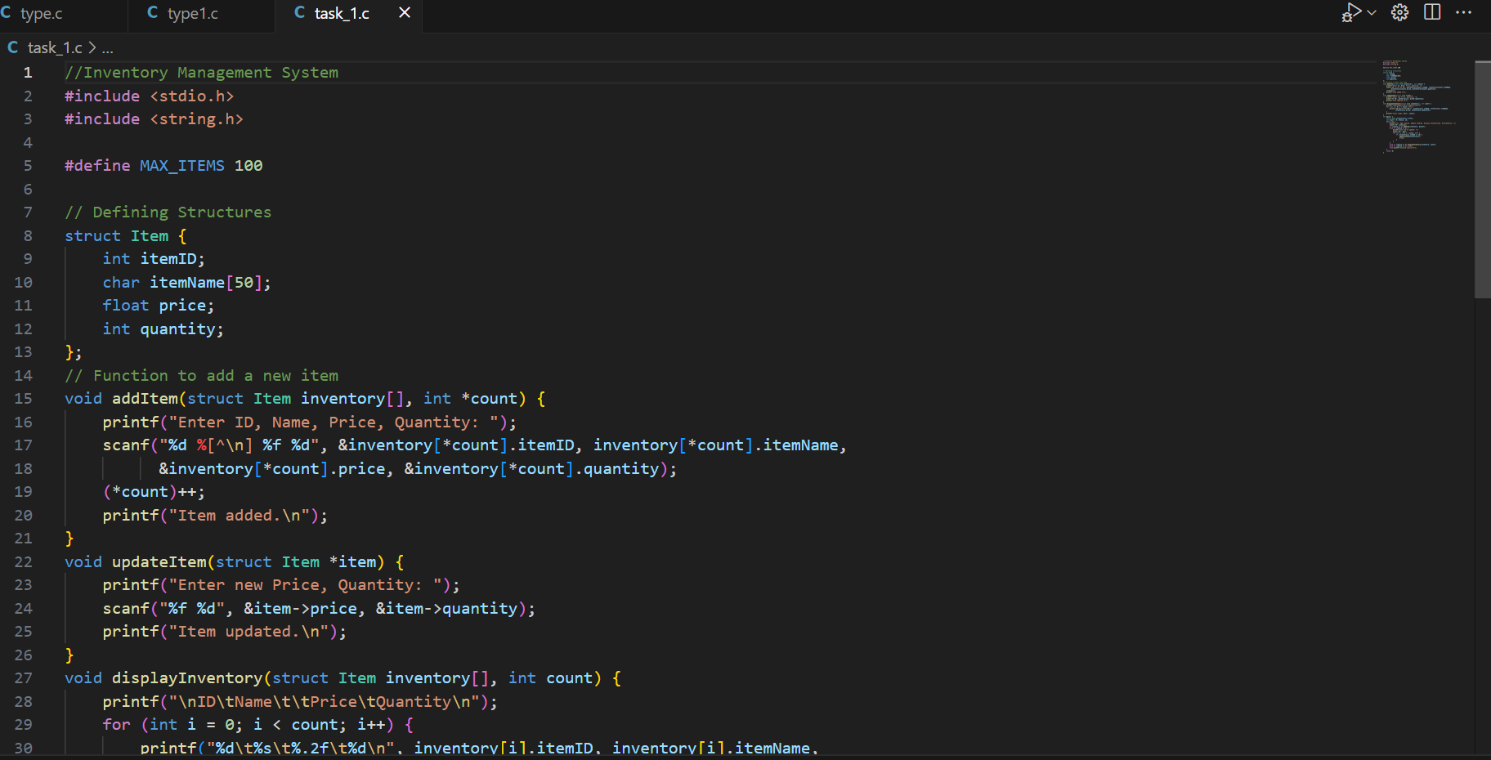

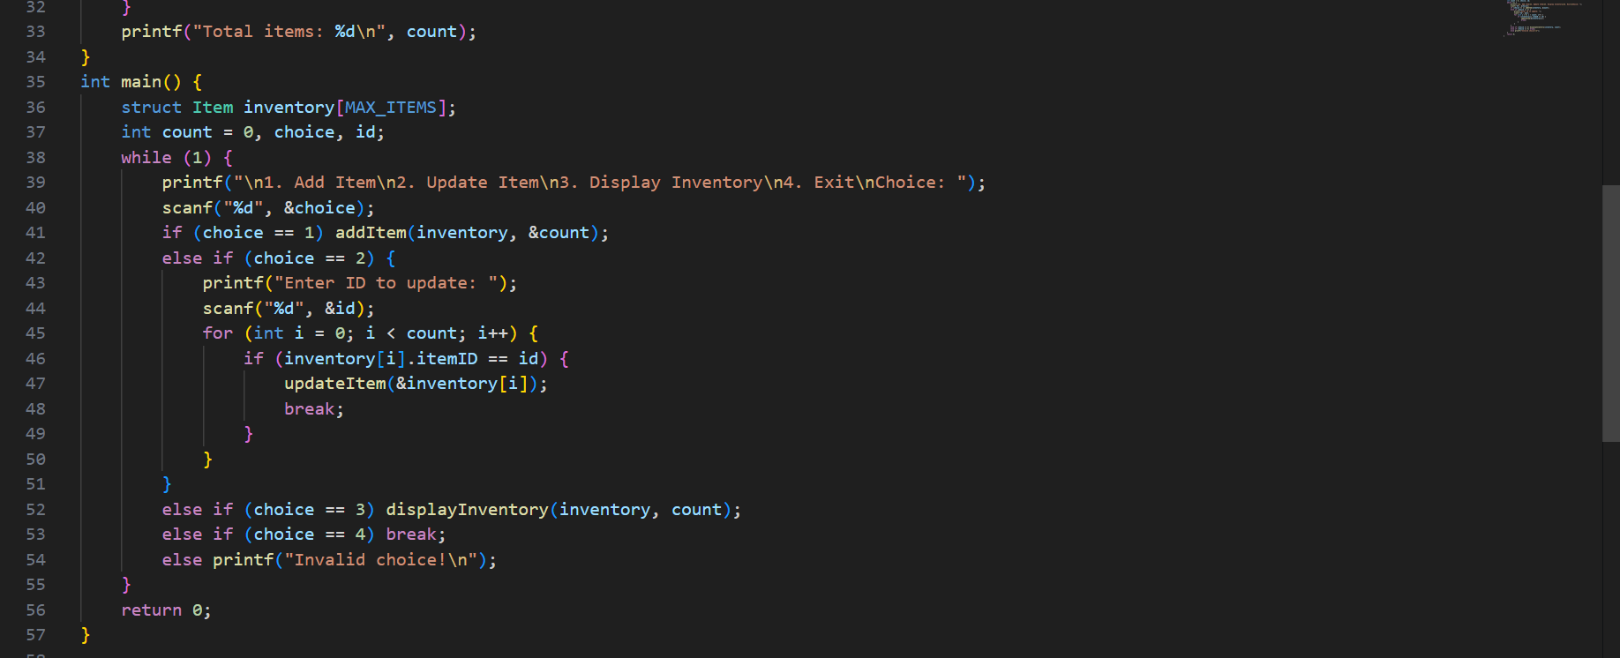

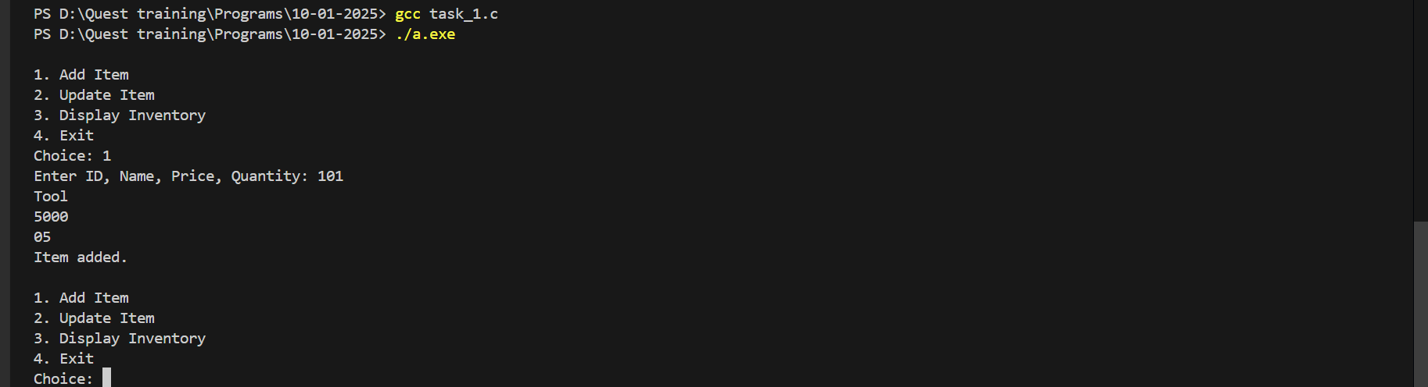

**Problem 2: Order Processing System**

**Description**: Create an order processing system that calculates the total order cost and applies discounts.

**Requirements**:

* Use a structure for Order containing fields for orderID, customerName, items (array), and totalCost.
* Use const for the discount rate.
* Implement functions for calculating the total cost (call by value) and applying the discount (call by reference).
* Use a loop to process multiple orders.

**Output Expectations**:

* Show the total cost before and after applying the discount for each order.

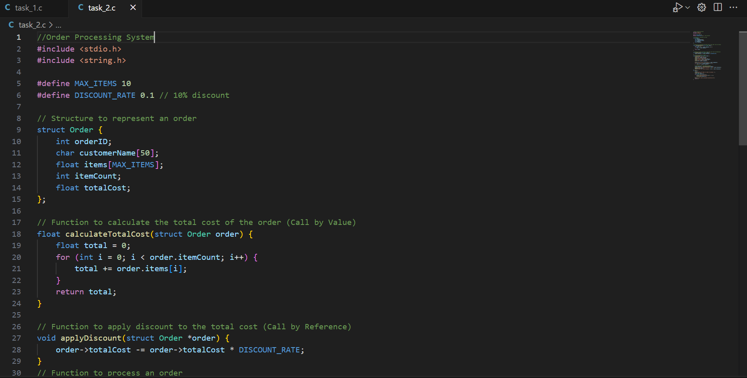

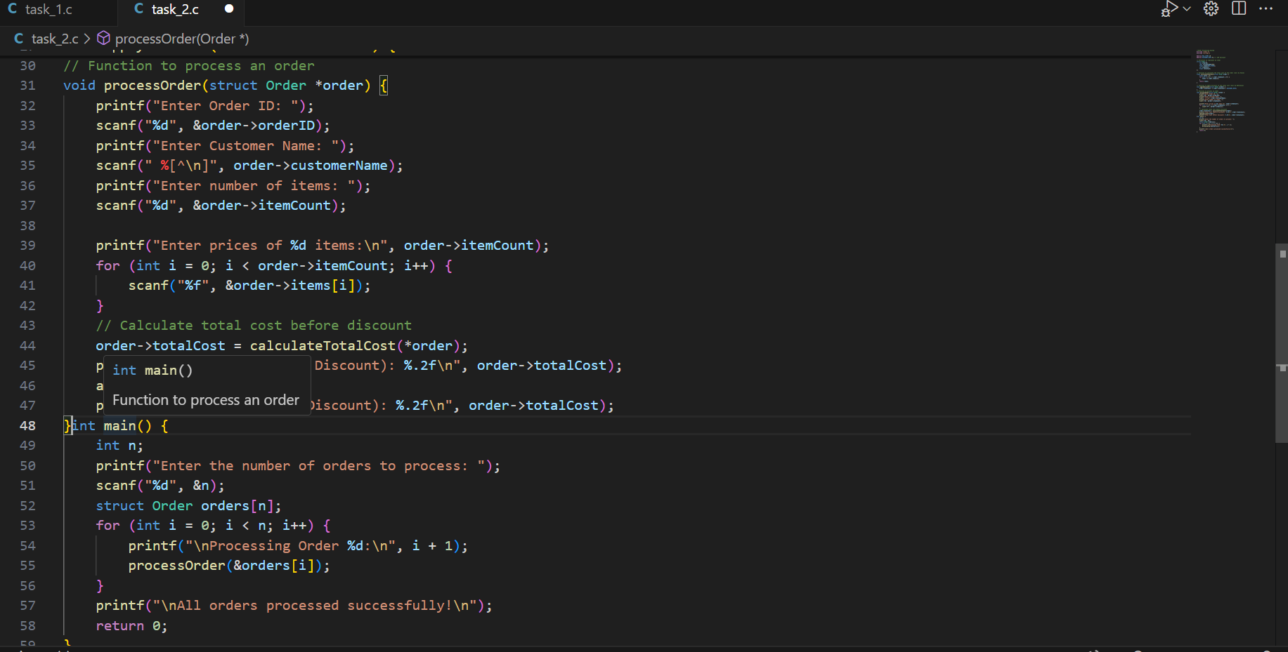

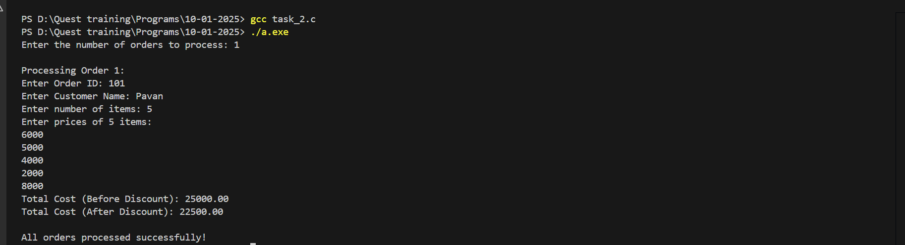

**Problem 3: Customer Feedback System**

**Description**: Develop a feedback system that categorizes customer feedback based on ratings.

**Requirements**:

* Use a structure to define Feedback with fields for customerID, feedbackText, and rating.
* Use a switch case to categorize feedback (e.g., Excellent, Good, Average, Poor).
* Store feedback in an array.
* Implement functions to add feedback and display feedback summaries using loops.

**Output Expectations**:

* Display categorized feedback summaries.

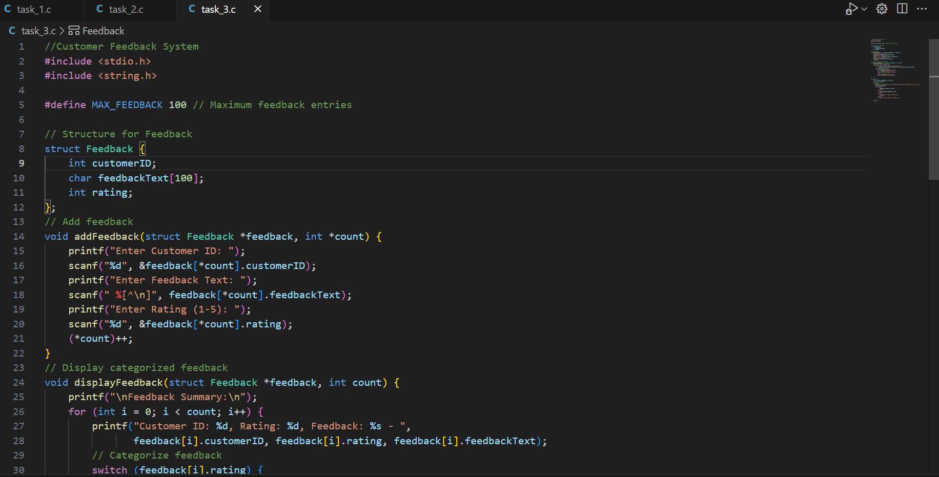

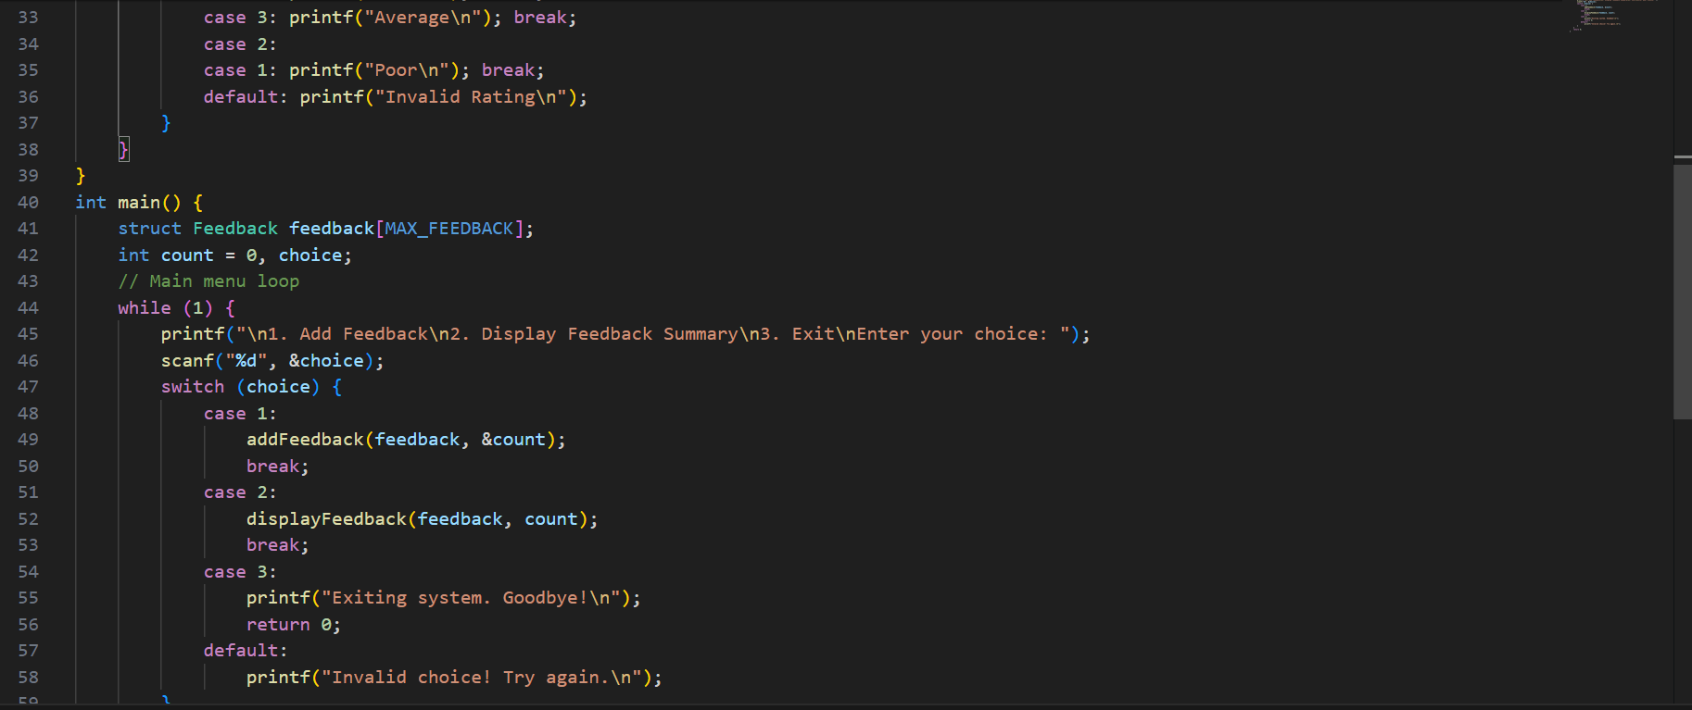

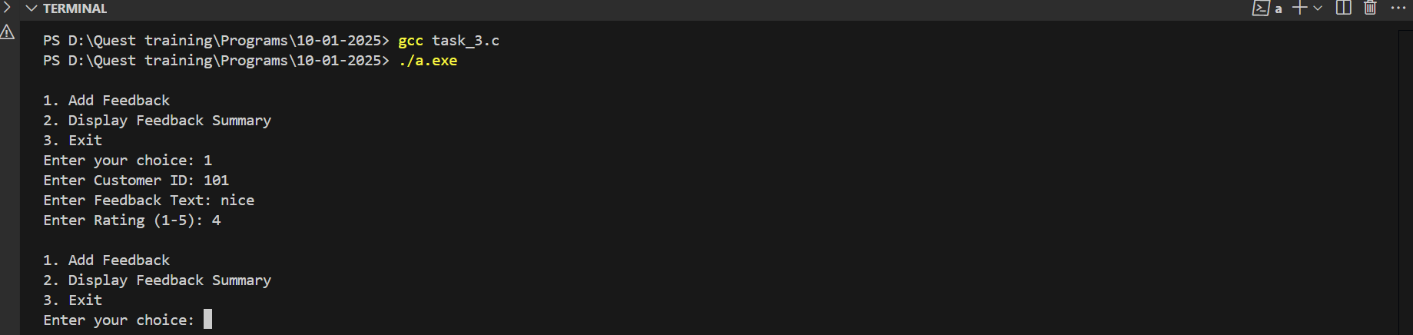

**Problem 4: Payment Method Selection**

**Description**: Write a program that handles multiple payment methods and calculates transaction charges.

**Requirements**:

* Use a structure for Payment with fields for method, amount, and transactionCharge.
* Use const for fixed transaction charges.
* Use a switch case to determine the transaction charge based on the payment method.
* Implement functions for processing payments and updating transaction details (call by reference).

**Output Expectations**:

* Show the payment details including the method and transaction charge.

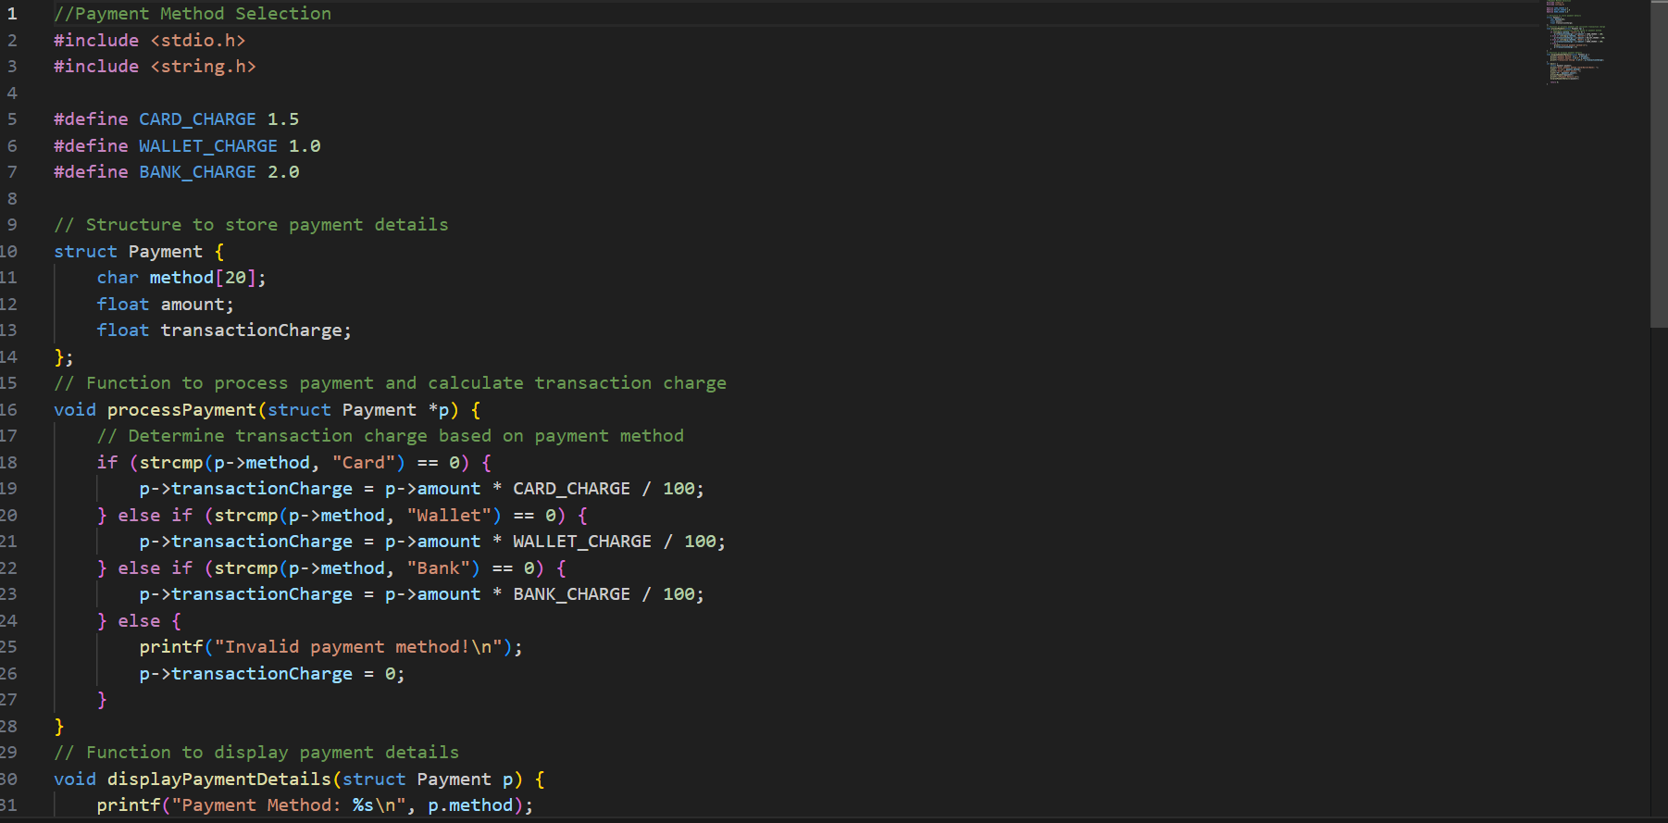

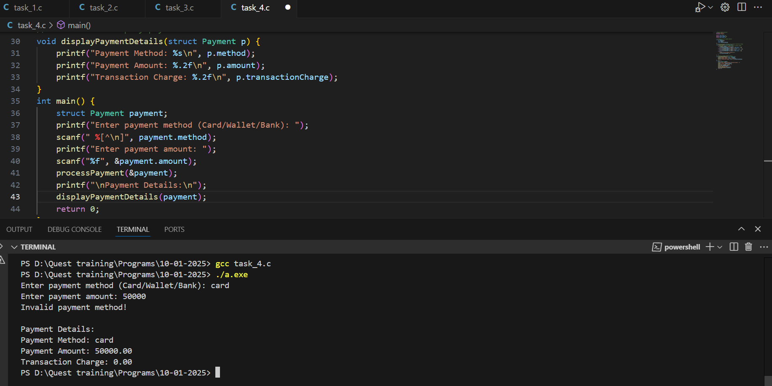

**Problem 5: Shopping Cart System**

**Description**: Implement a shopping cart system that allows adding, removing, and viewing items.

**Requirements**:

* Use a structure for CartItem with fields for itemID, itemName, price, and quantity.
* Use an array to store the cart items.
* Implement functions to add, remove (call by reference), and display items (call by value).
* Use loops for iterating through cart items.

**Output Expectations**:

* Display the updated cart after each operation.

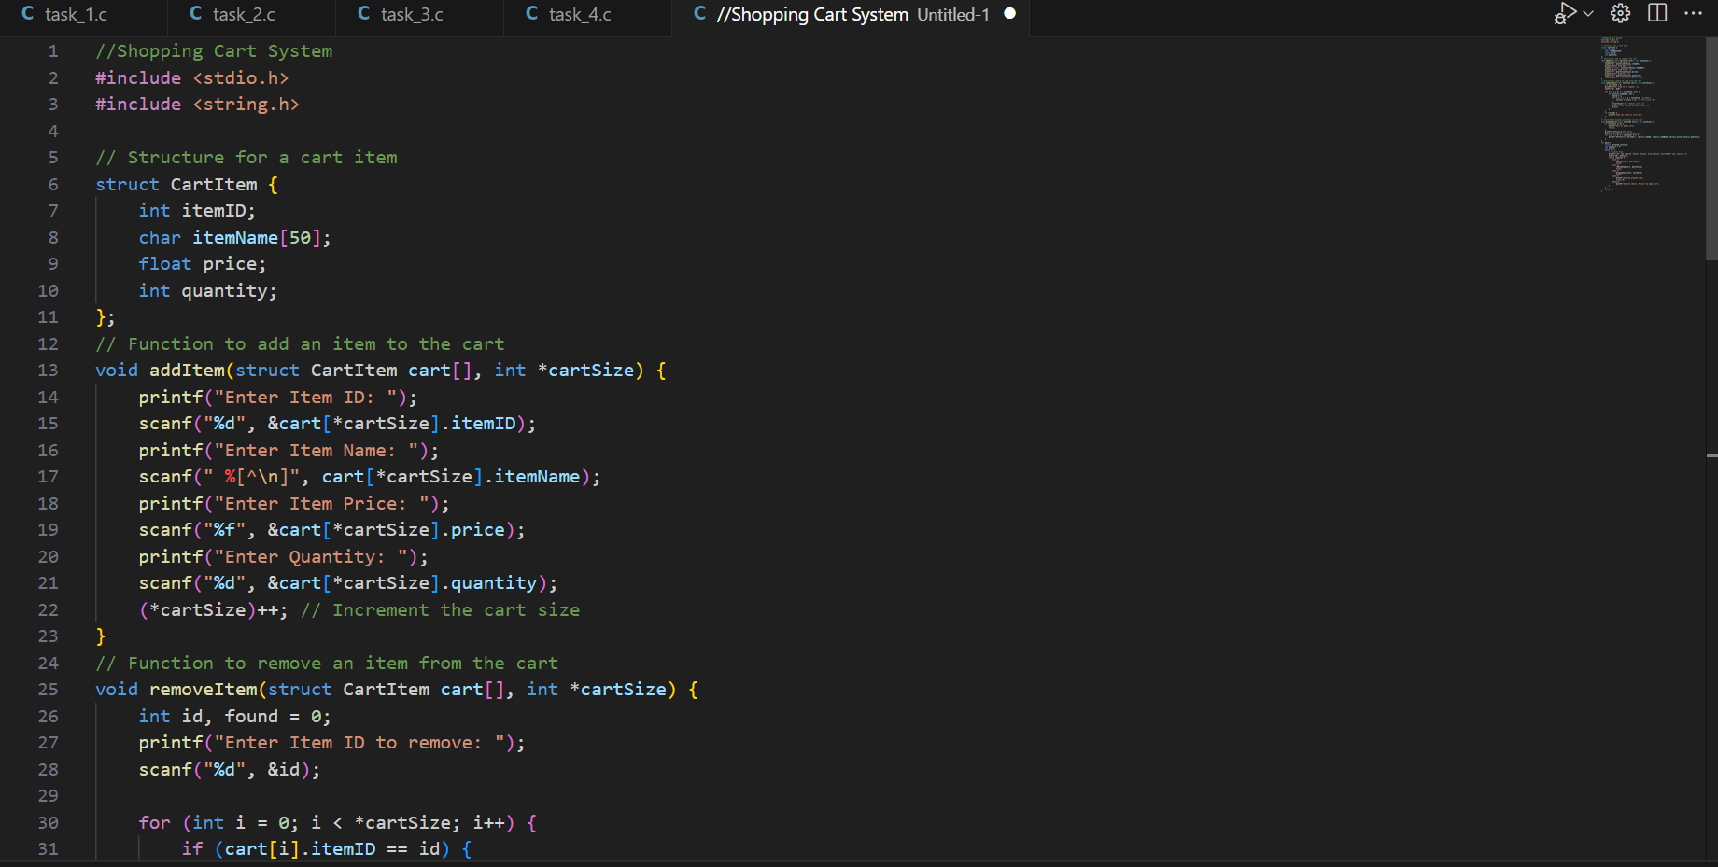

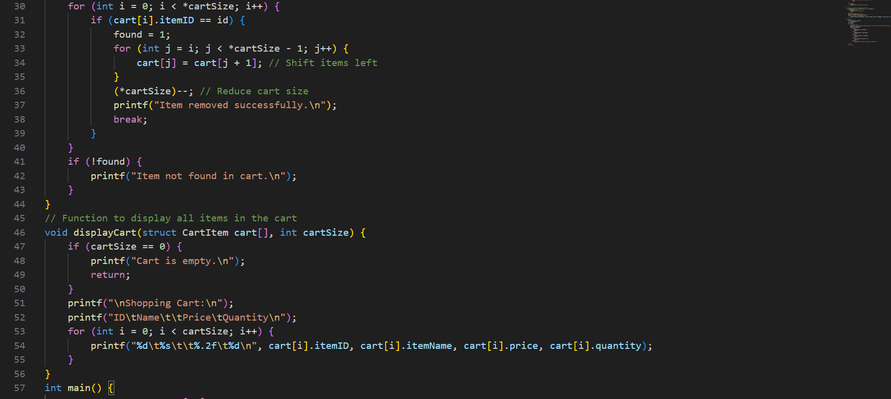

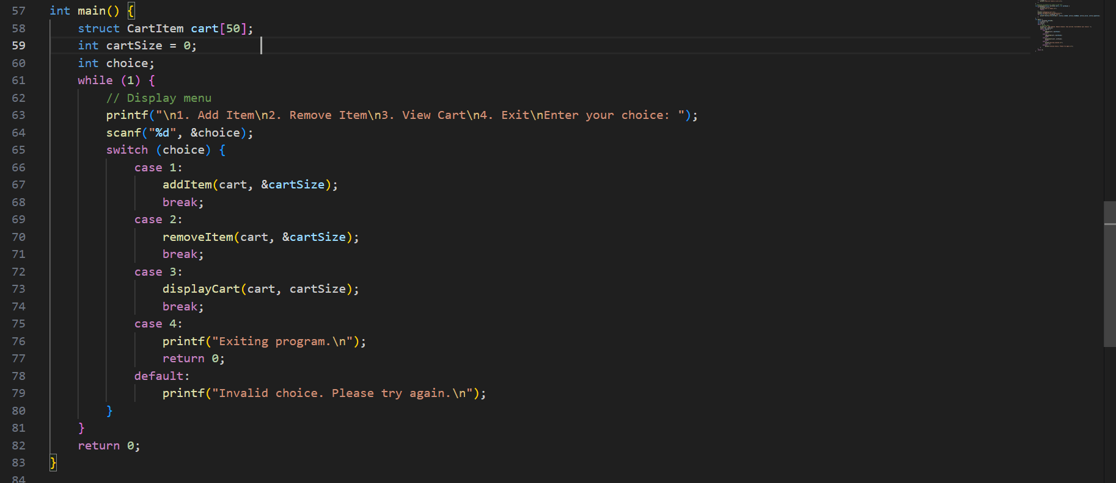

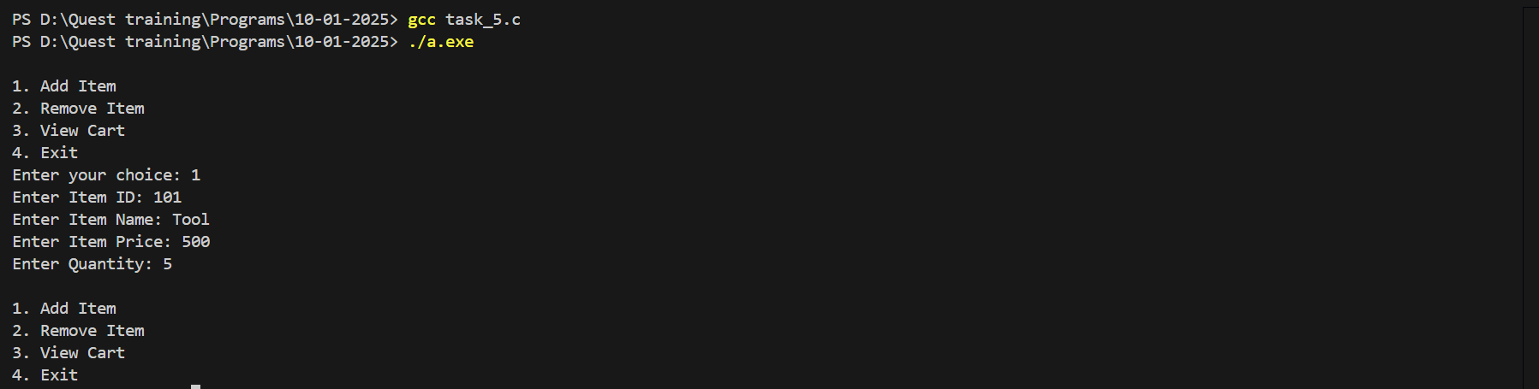

**Problem 6: Product Search System**

**Description**: Create a system that allows searching for products by name or ID.

**Requirements**:

* Use a structure for Product with fields for productID, productName, category, and price.
* Store products in an array.
* Use a loop to search for a product.
* Implement functions for searching by name (call by value) and updating details (call by reference).

**Output Expectations**:

* Display product details if found or a message indicating the product is not found.

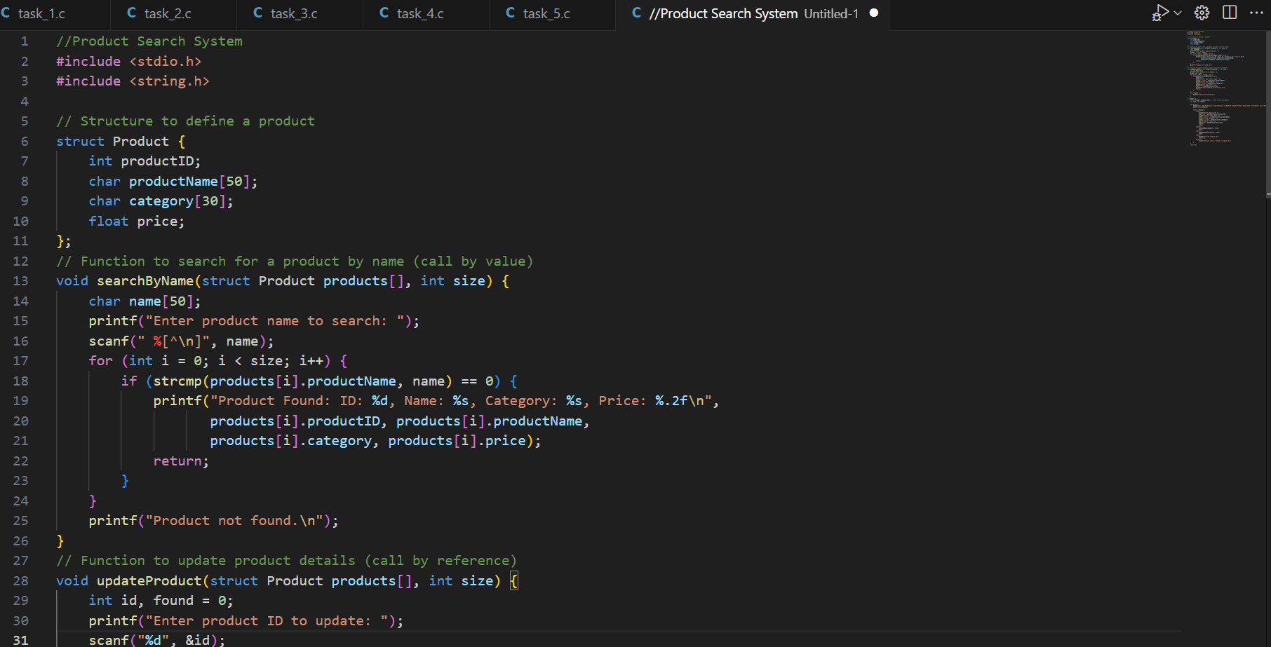

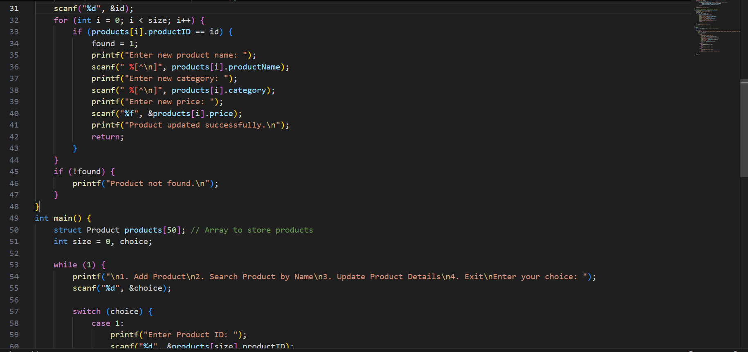

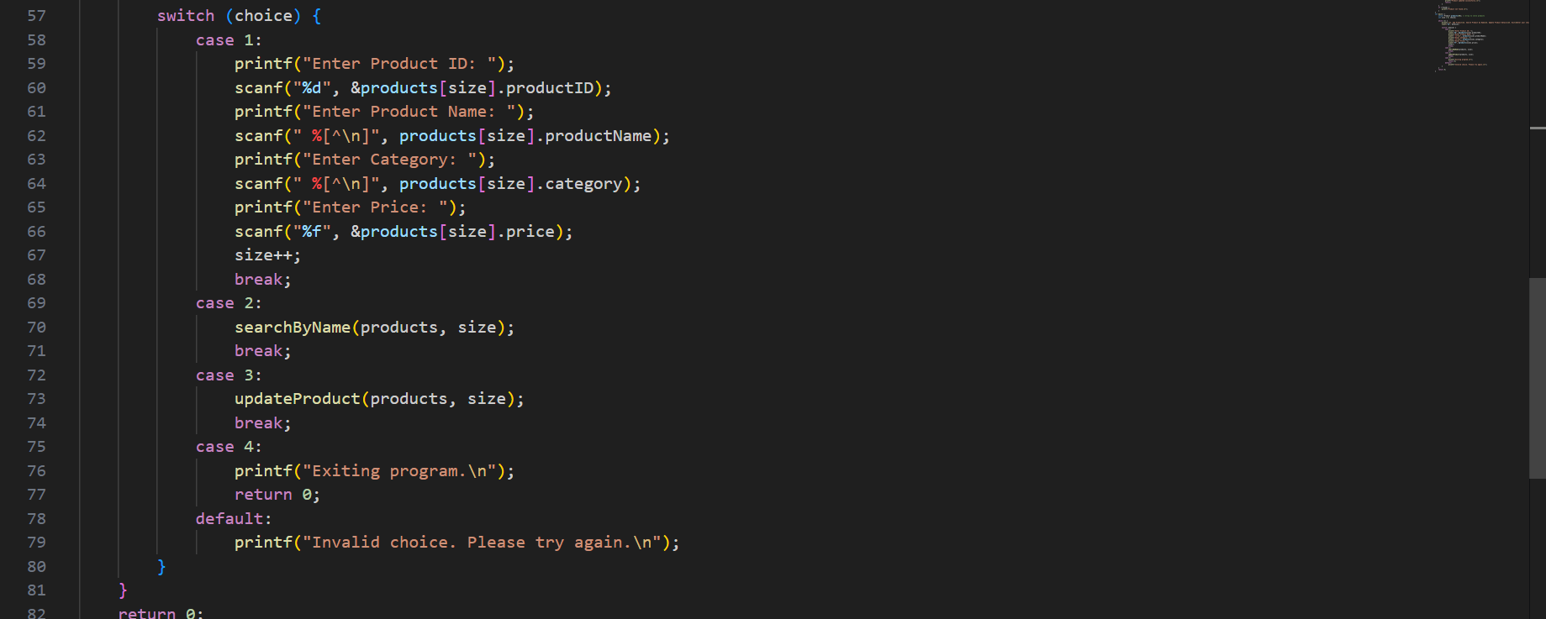

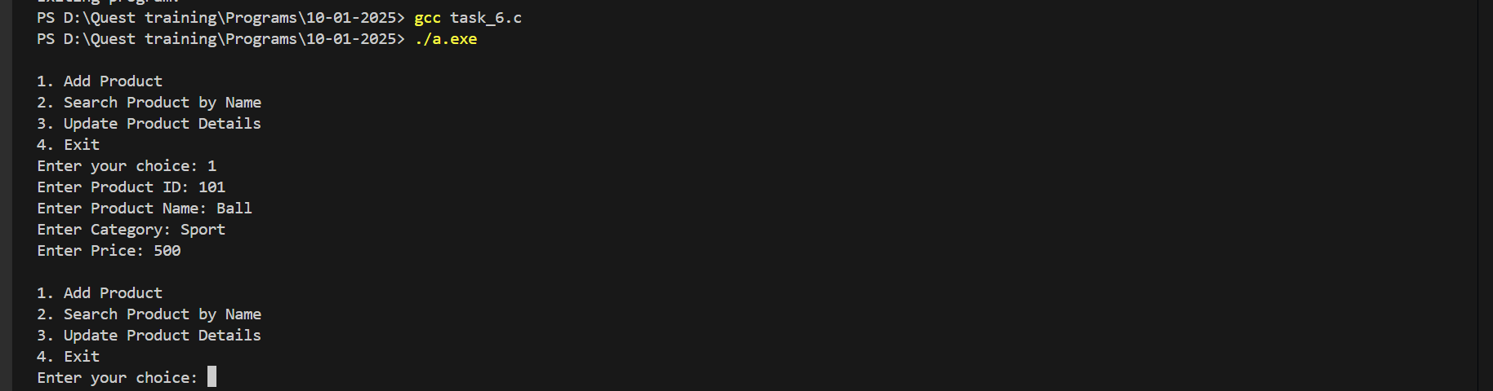

**Problem 7: Sales Report Generator**

**Description**: Develop a system that generates a sales report for different categories.

**Requirements**:

* Use a structure for Sale with fields for saleID, productCategory, amount, and date.
* Store sales in an array.
* Use a loop and switch case to categorize and summarize sales.
* Implement functions to add sales data and generate reports.

**Output Expectations**:

* Display summarized sales data by category.

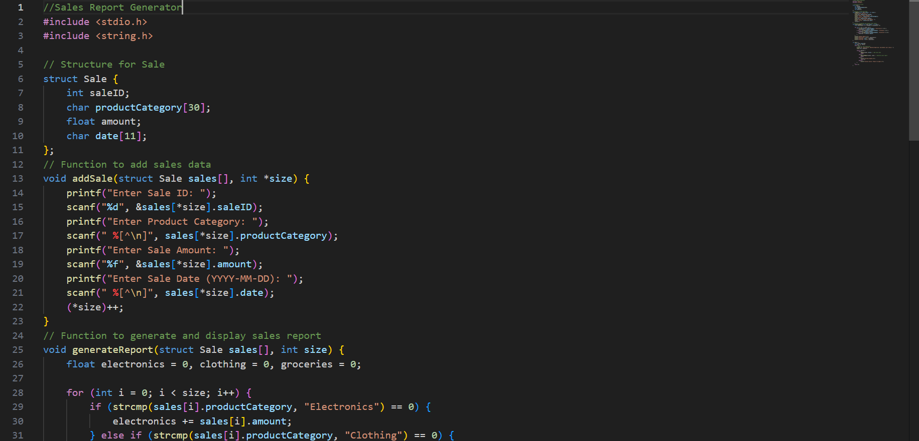

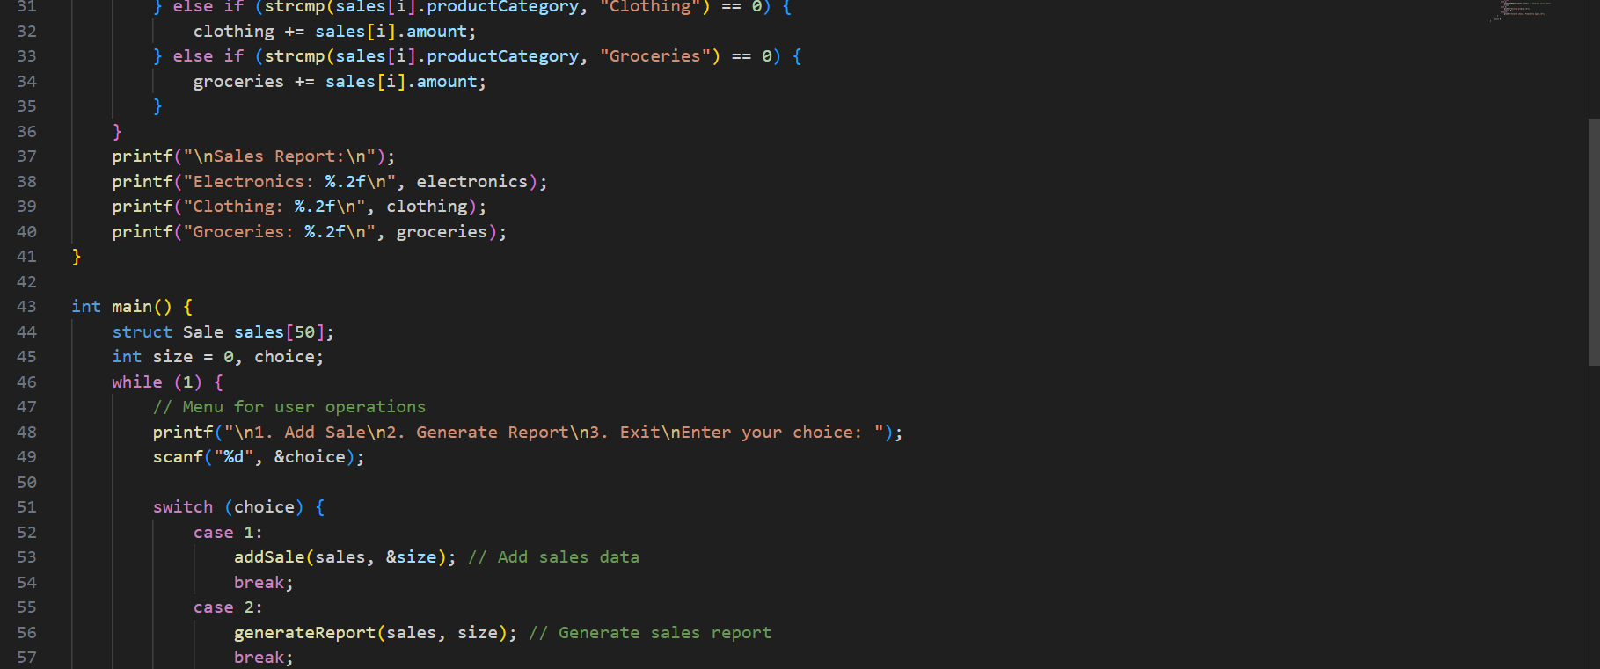

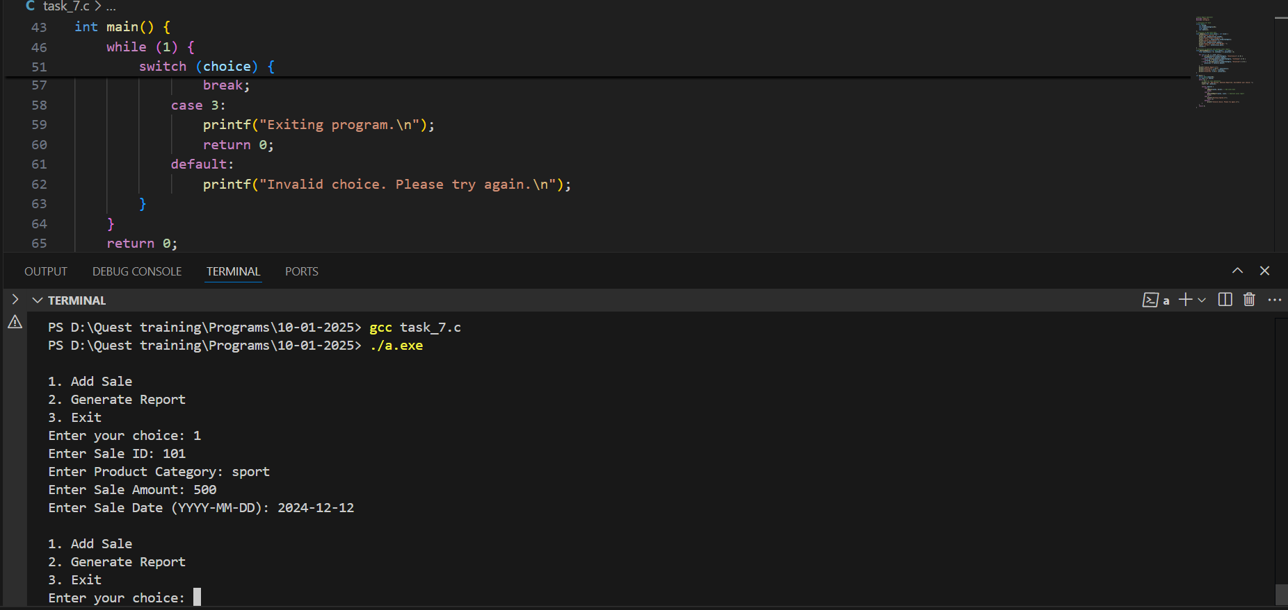

**Problem 8: Customer Loyalty Program**

**Description**: Implement a loyalty program that rewards customers based on their total purchase amount.

**Requirements**:

* Use a structure for Customer with fields for customerID, name, totalPurchases, and rewardPoints.
* Use const for the reward rate.
* Implement functions to calculate and update reward points (call by reference).
* Use a loop to process multiple customers.

**Output Expectations**:

* Display customer details including reward points after updating.

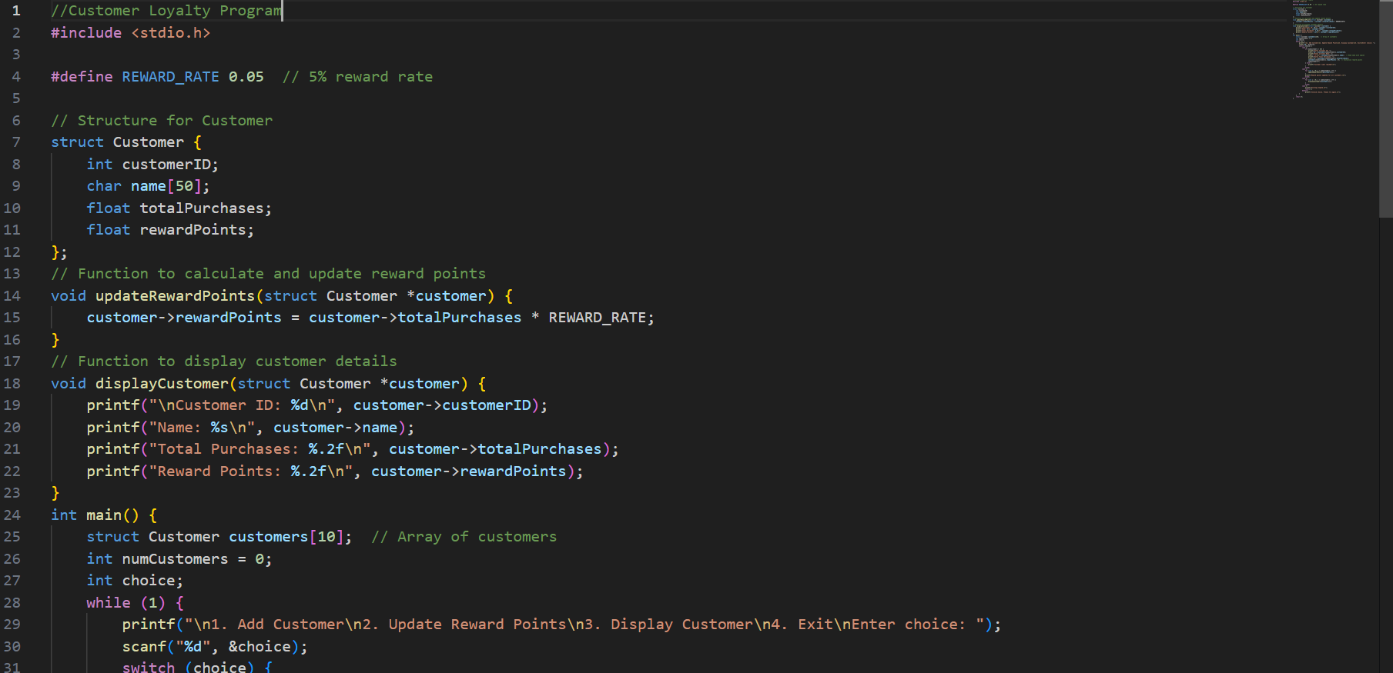

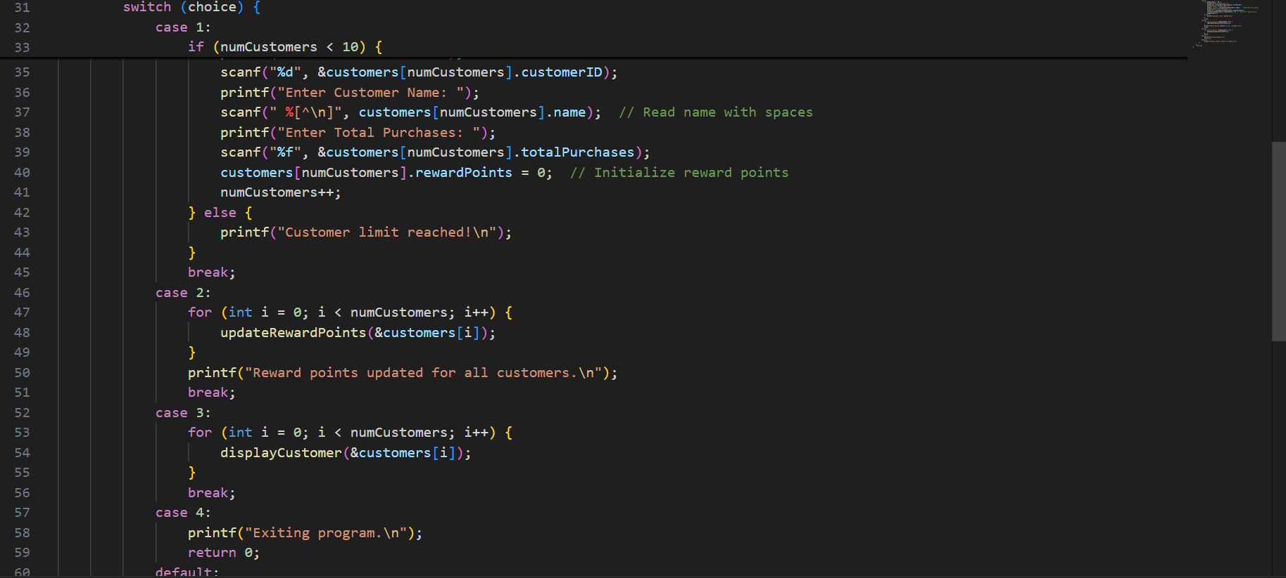

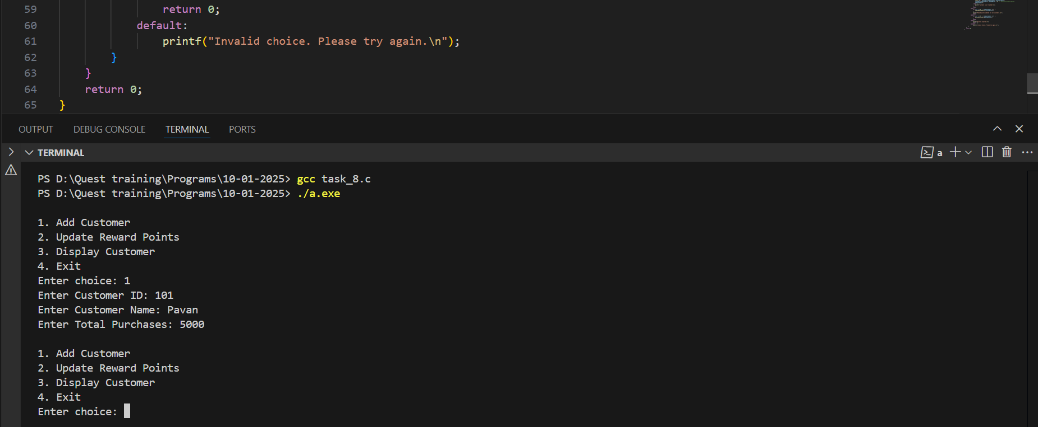

**Problem 9: Warehouse Management System**

**Description**: Create a warehouse management system to track stock levels of different products.

**Requirements**:

* Use a structure for WarehouseItem with fields for itemID, itemName, currentStock, and reorderLevel.
* Use an array to store warehouse items.
* Implement functions to update stock levels (call by reference) and check reorder status (call by value).
* Use a loop for updating stock.

**Output Expectations**:

* Display the stock levels and reorder status for each item.

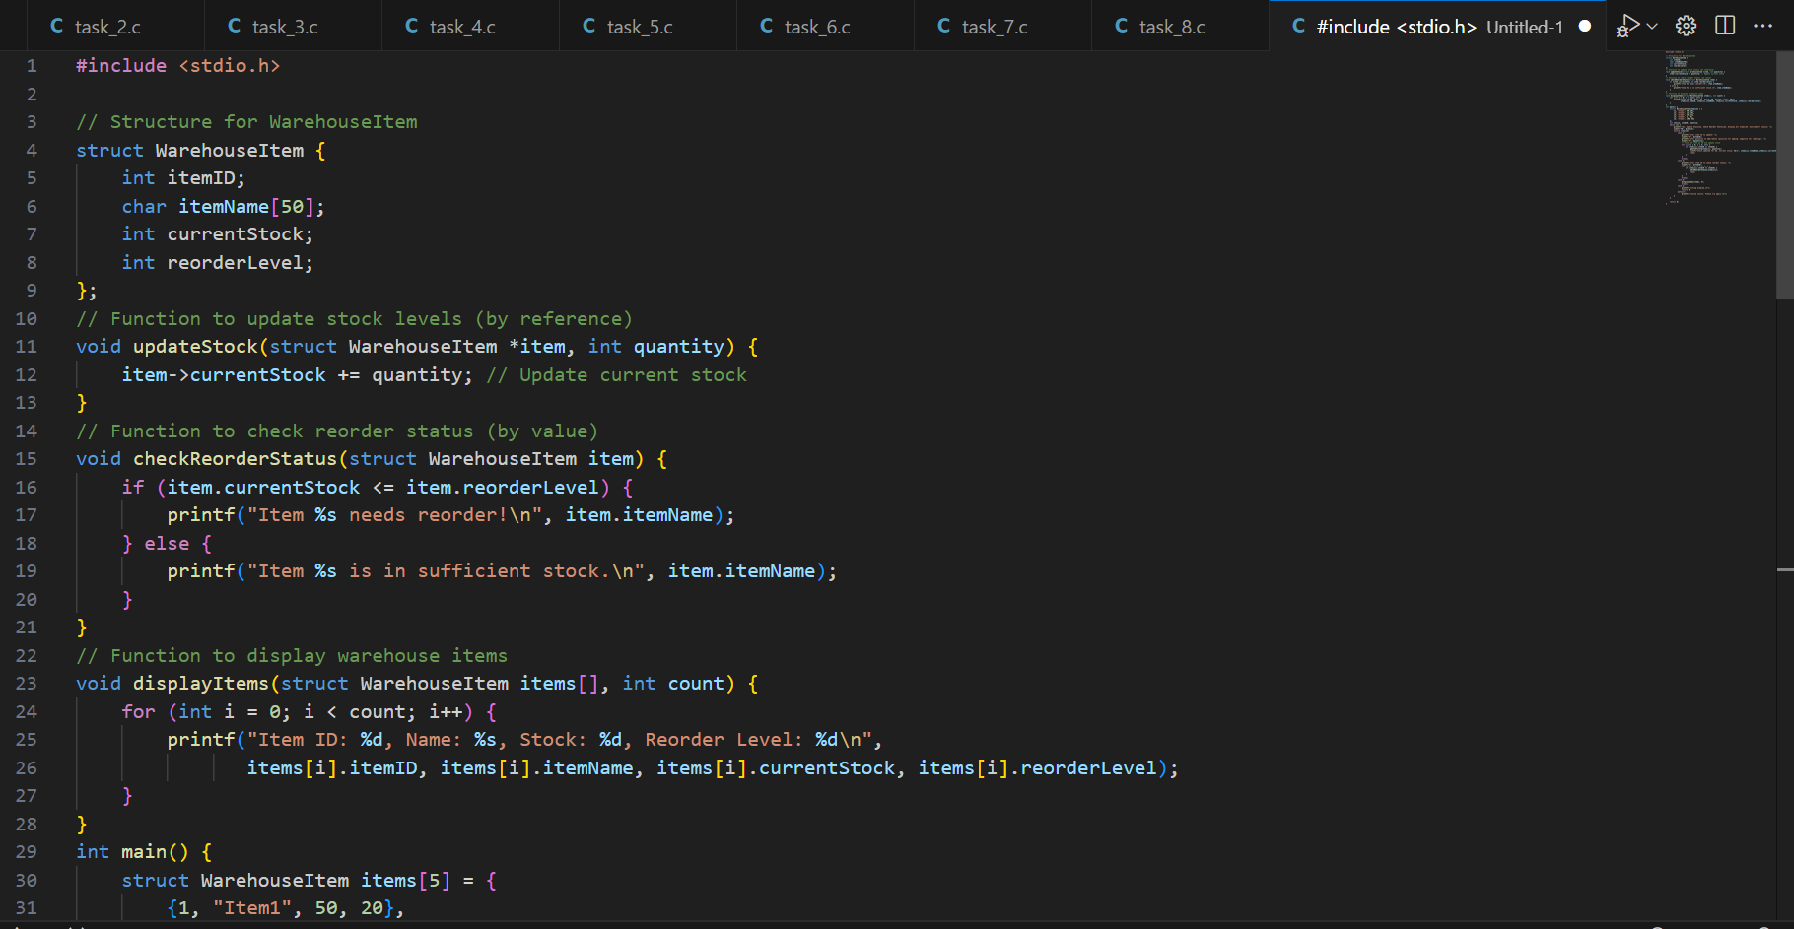

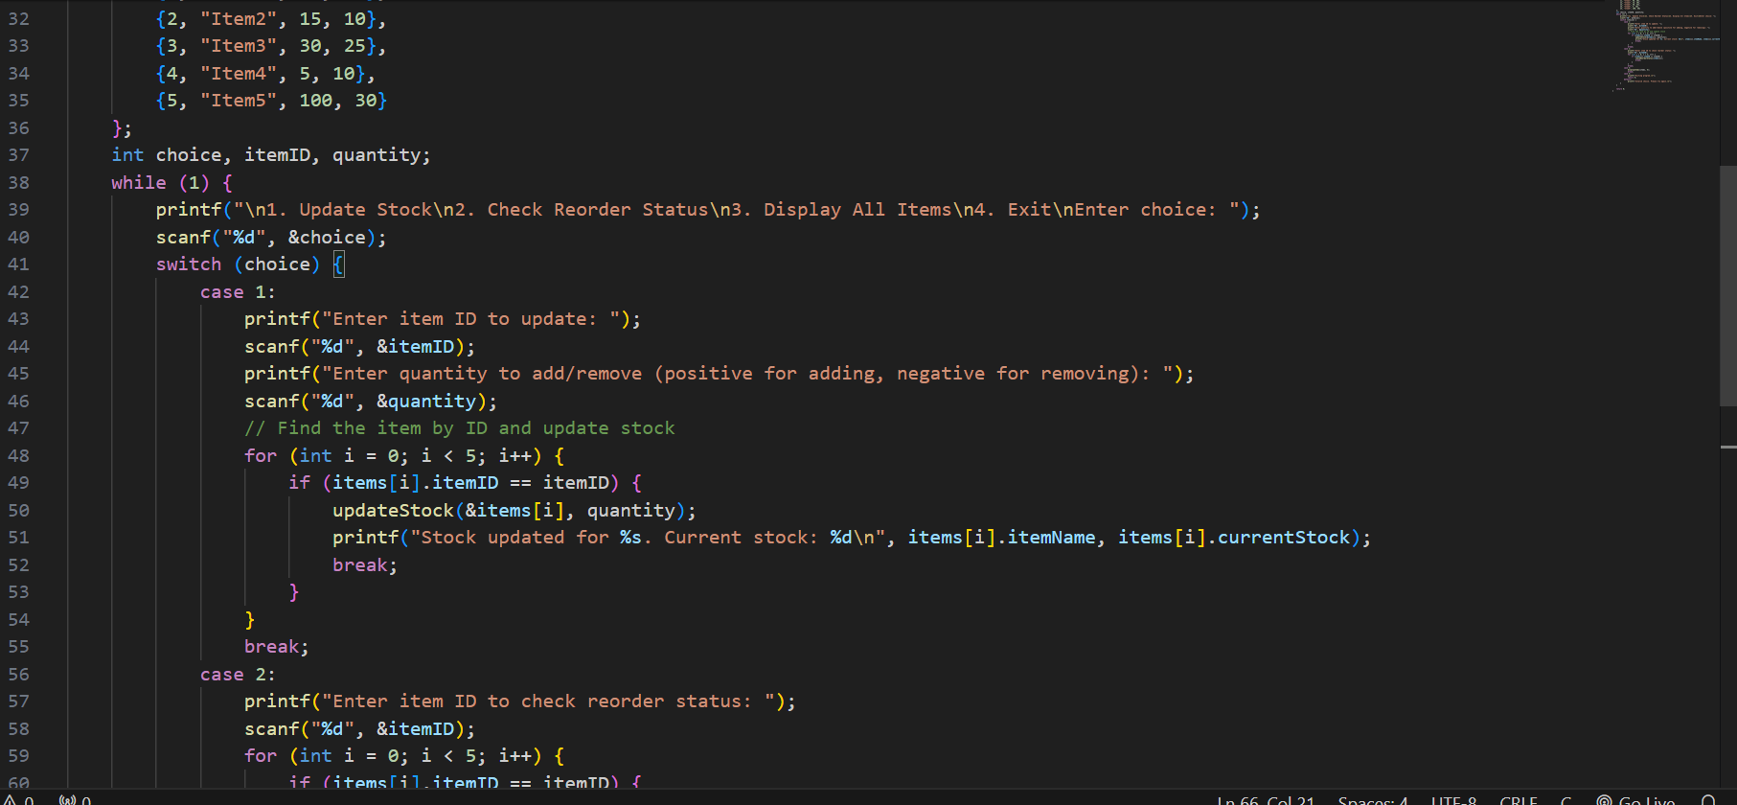

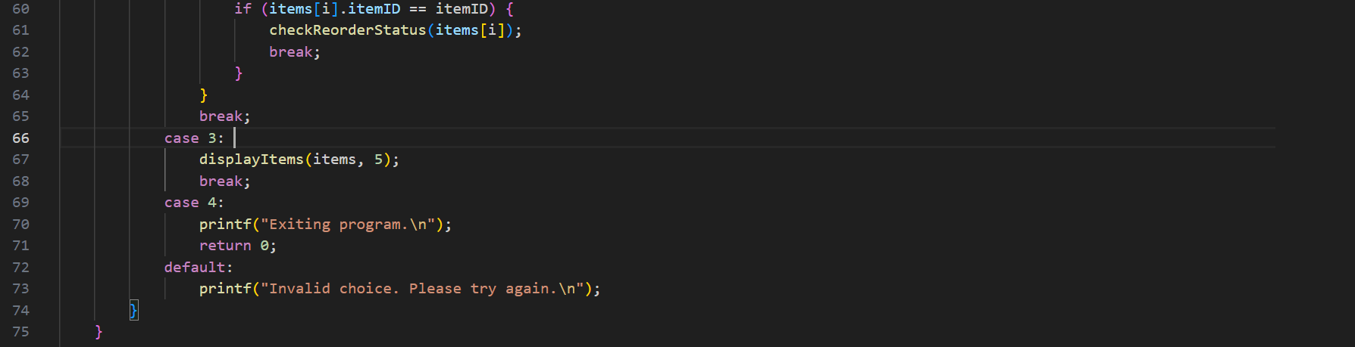

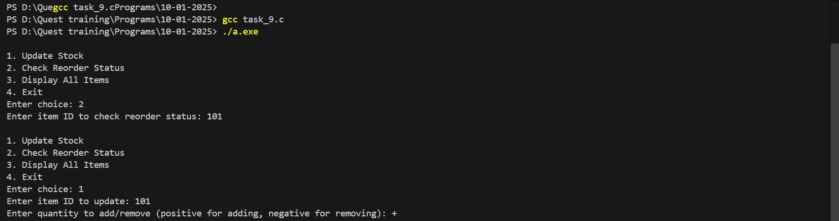

**Problem 10: Discount Management System**

**Description**: Design a system that manages discounts for different product categories.

**Requirements**:

* Use a structure for Discount with fields for category, discountPercentage, and validTill.
* Use const for predefined categories.
* Use a switch case to apply discounts based on the category.
* Implement functions to update and display discounts (call by reference).

**Output Expectations**:

* Show the updated discount details for each category.

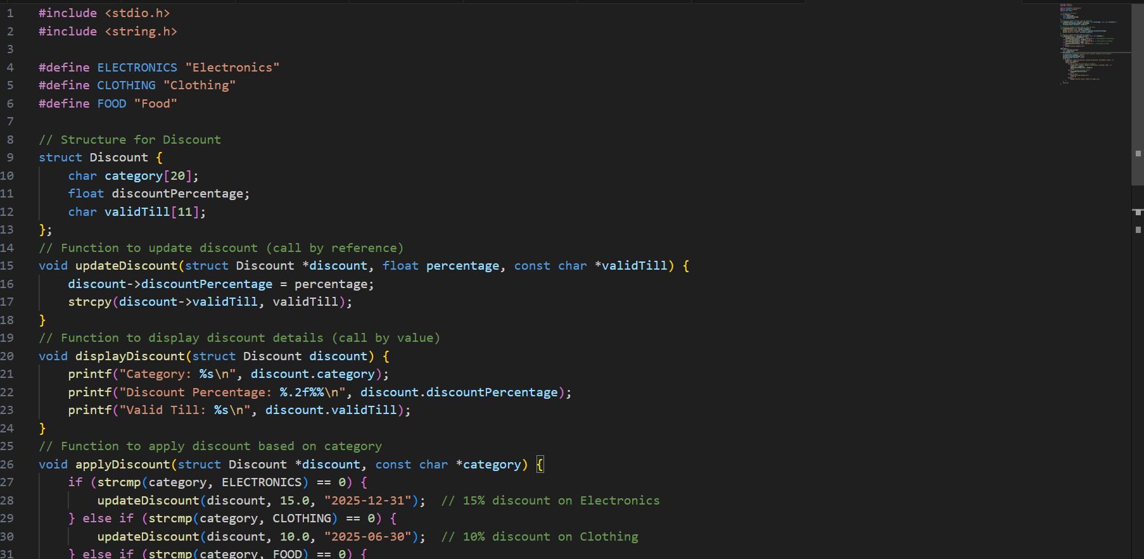

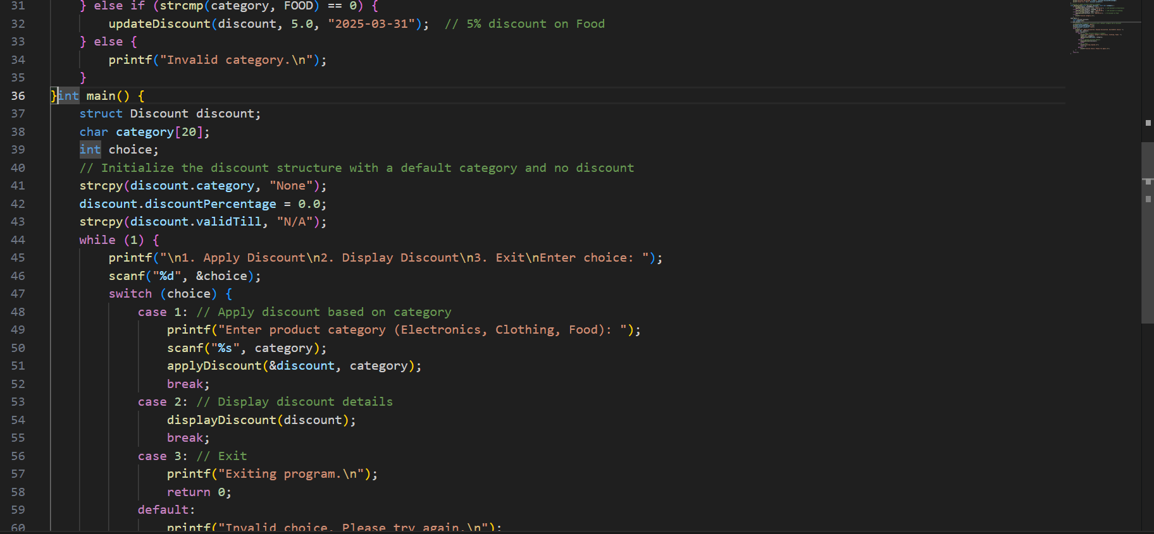

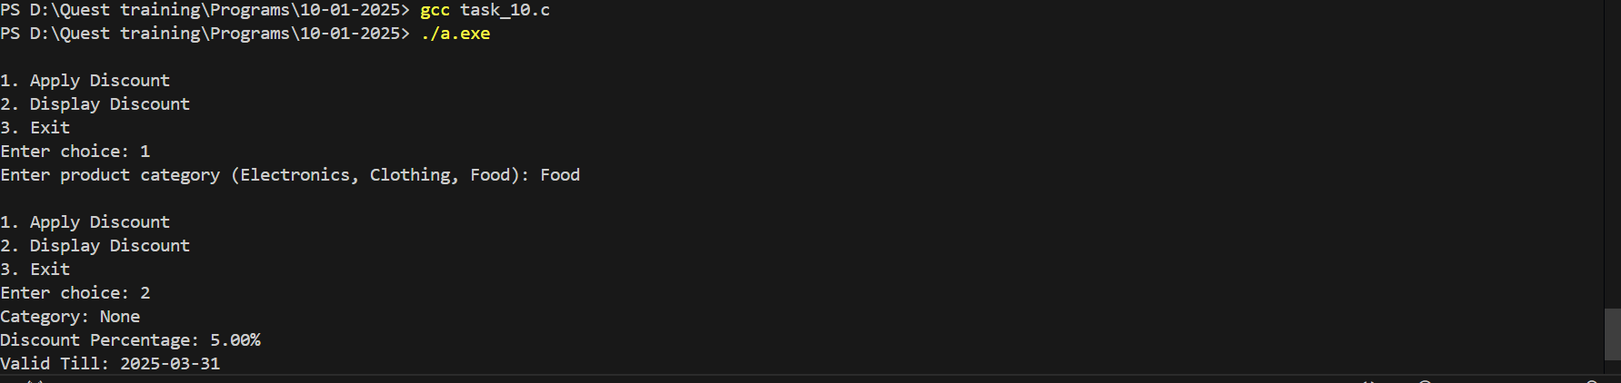

**UNION**

**Problem 1: Union for Mixed Data**

**Description**: Create a union that can store an integer, a float, or a character. Write a program that assigns values to each member and displays them.

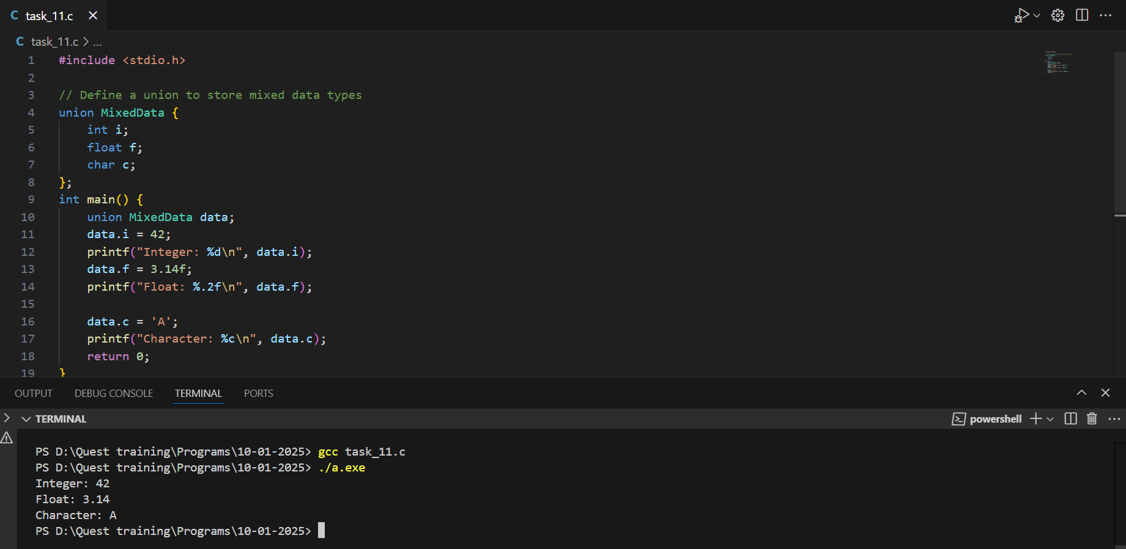

**Problem 2: Student Data with Union**

**Description**: Define a union to store either a student’s roll number (integer) or name (string). Write a program to input and display student details using the union.

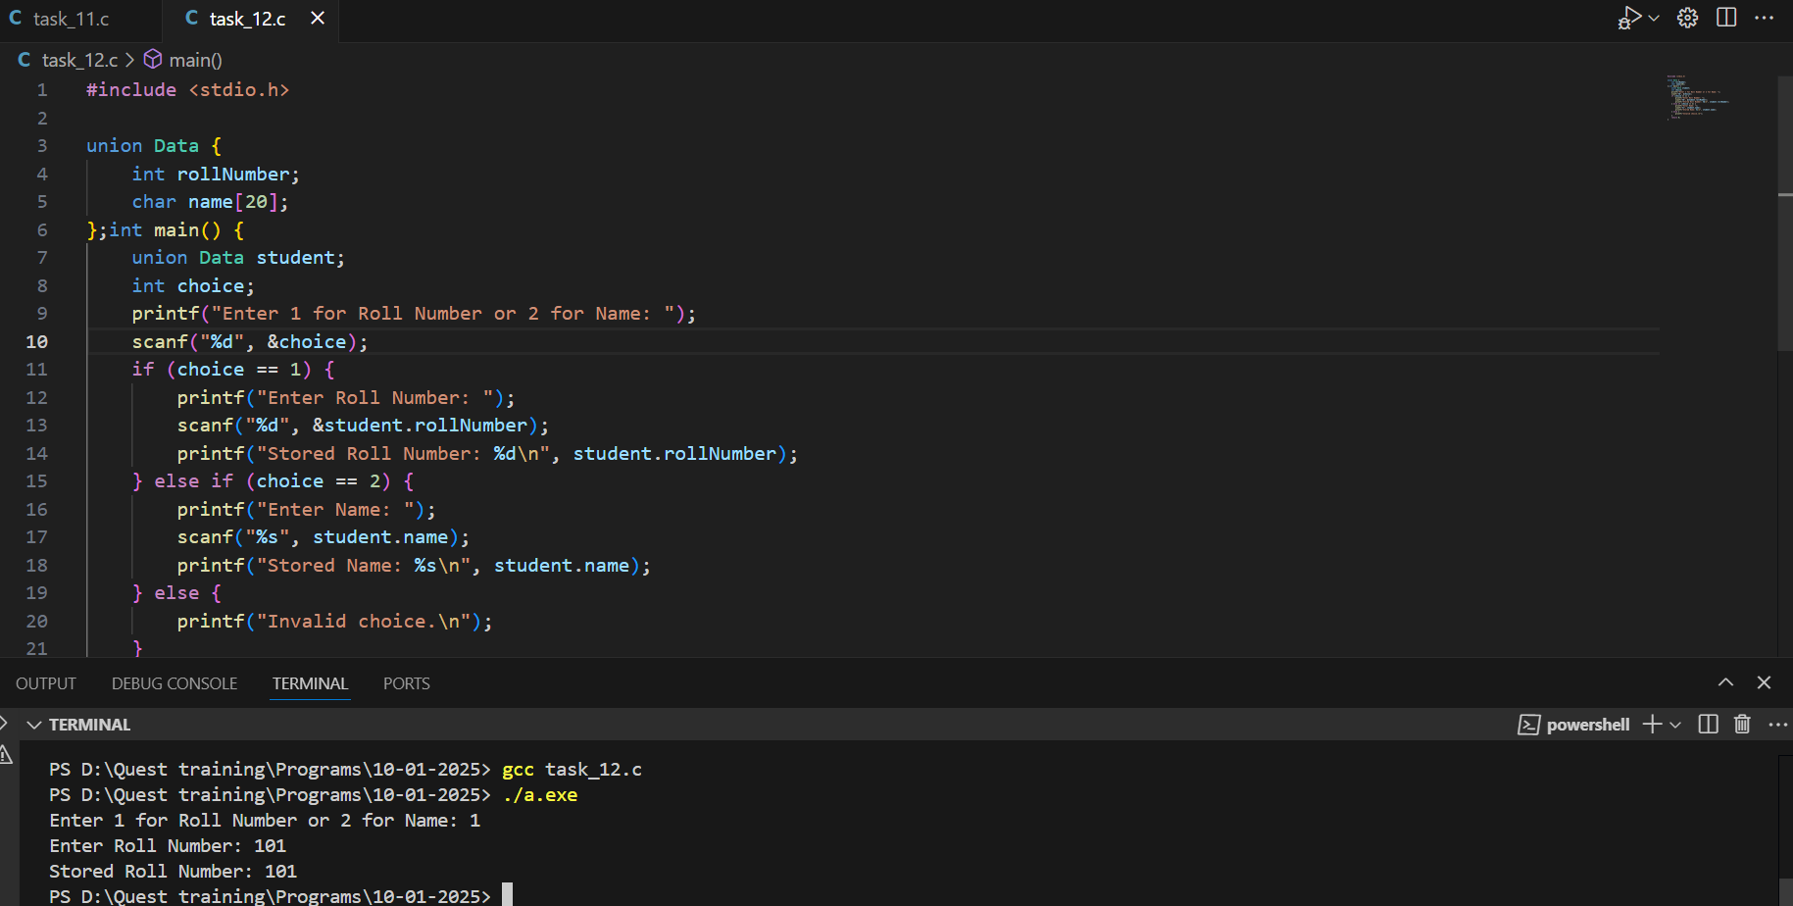

**Problem 3: Union for Measurement Units**

**Description**: Create a union that can store a distance in either kilometers (float) or miles (float). Write a program to convert and display the distance in both units.

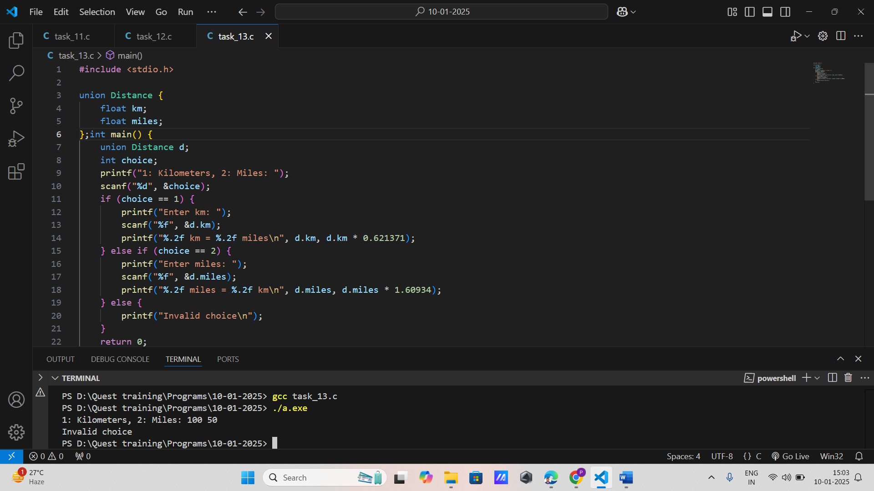

**Problem 4: Union for Shape Dimensions**

**Description**: Define a union to store dimensions of different shapes: a radius (float) for a circle, length and width (float) for a rectangle. Write a program to calculate and display the area based on the selected shape.

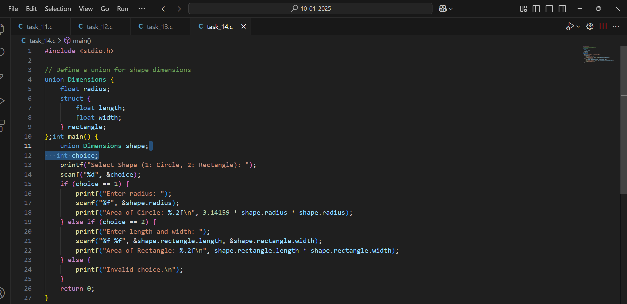

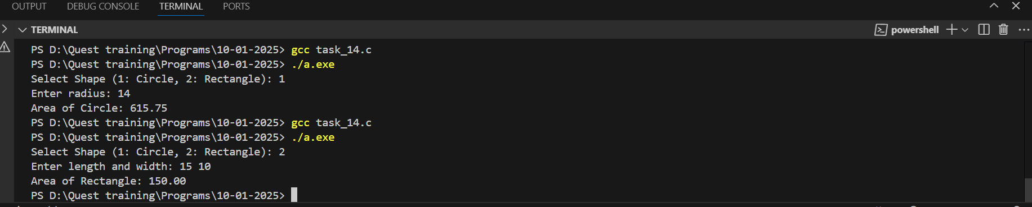

**Problem 5: Union for Employee Data**

**Description**: Create a union to store either an employee’s ID (integer) or salary (float). Write a program to input and display either ID or salary based on user choice.

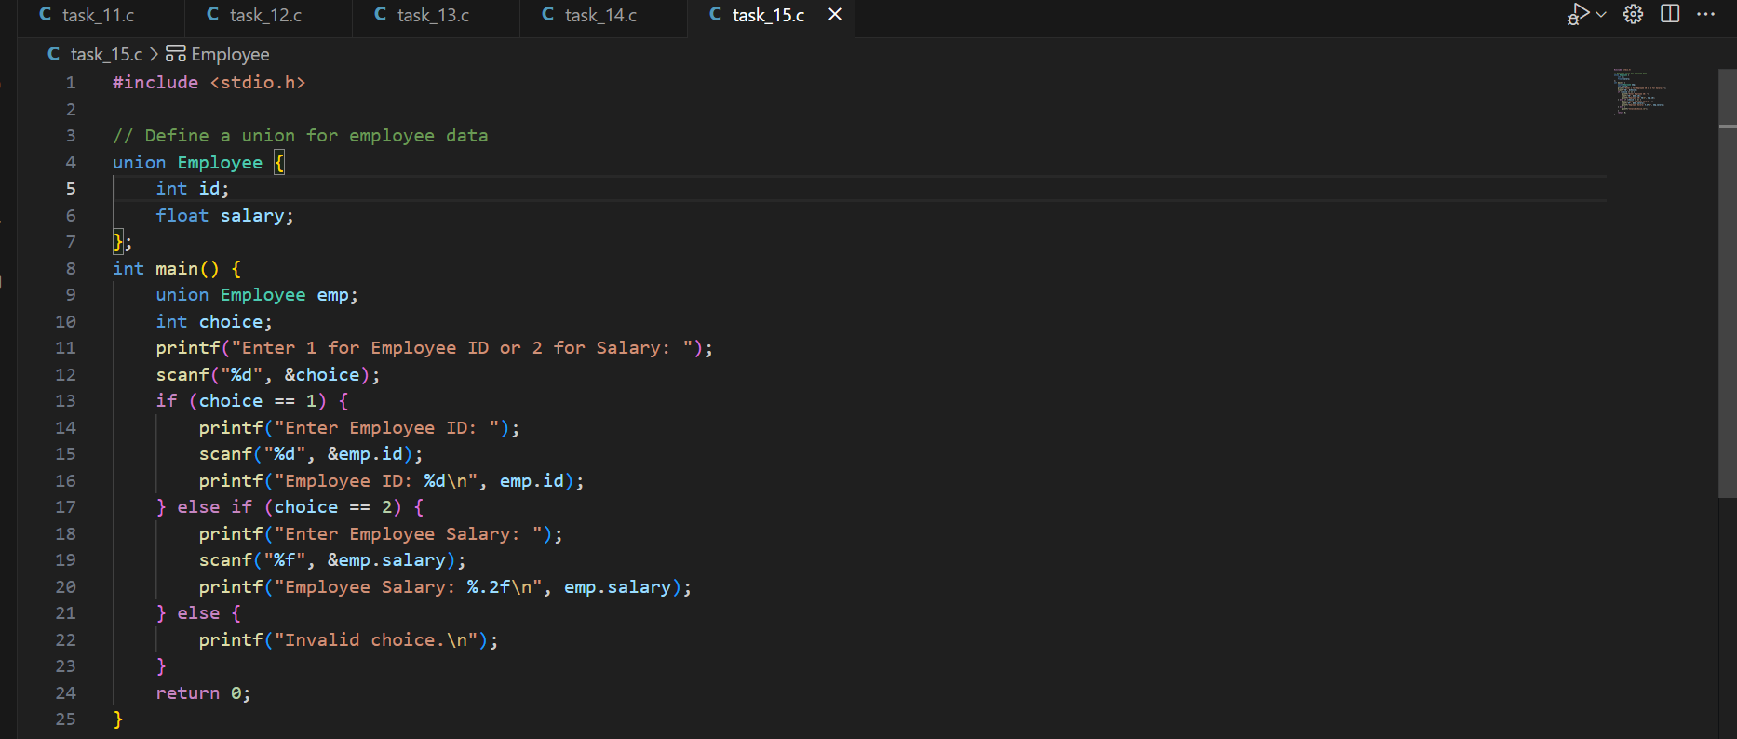



**Problem 6: Union for Sensor Data**

**Description**: Define a union to store sensor data, either temperature (float) or pressure (float). Write a program to simulate sensor readings and display the data.

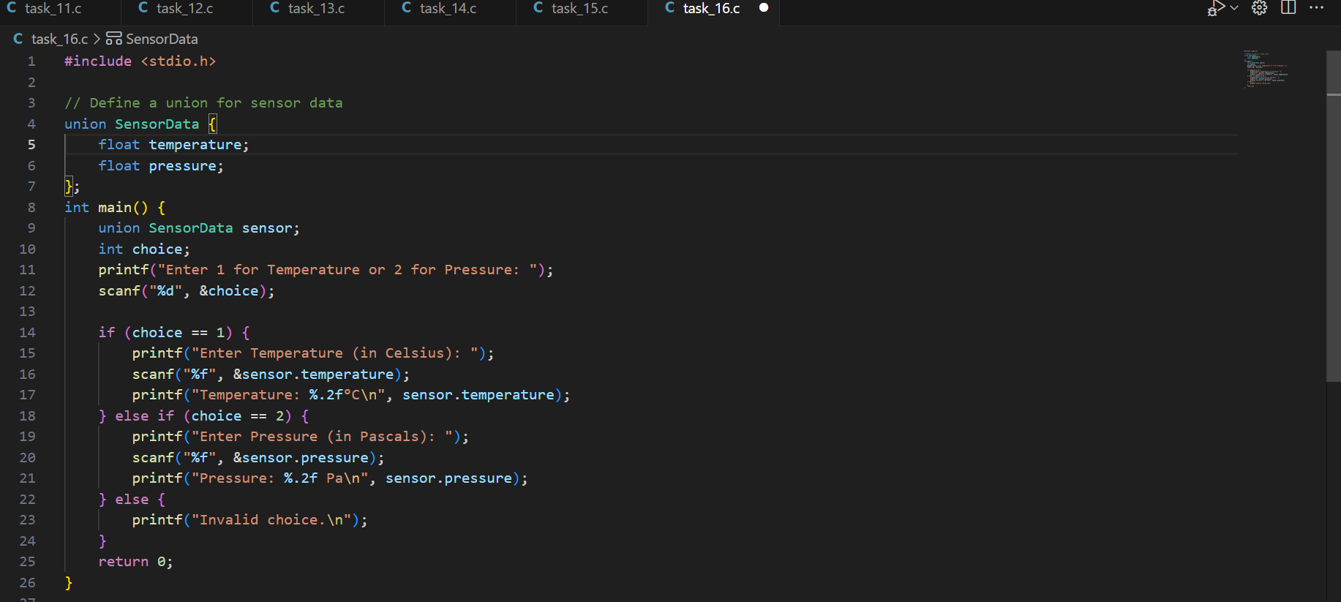

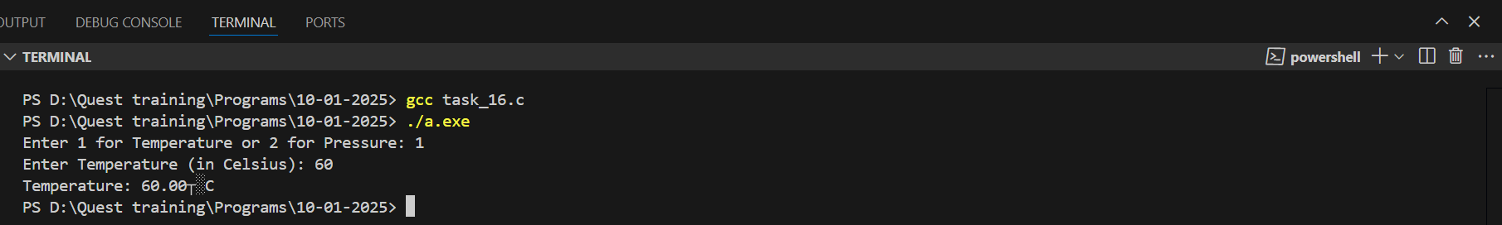

**Problem 7: Union for Bank Account Information**

**Description**: Create a union to store either a bank account number (integer) or balance (float). Write a program to input and display either the account number or balance based on user input.

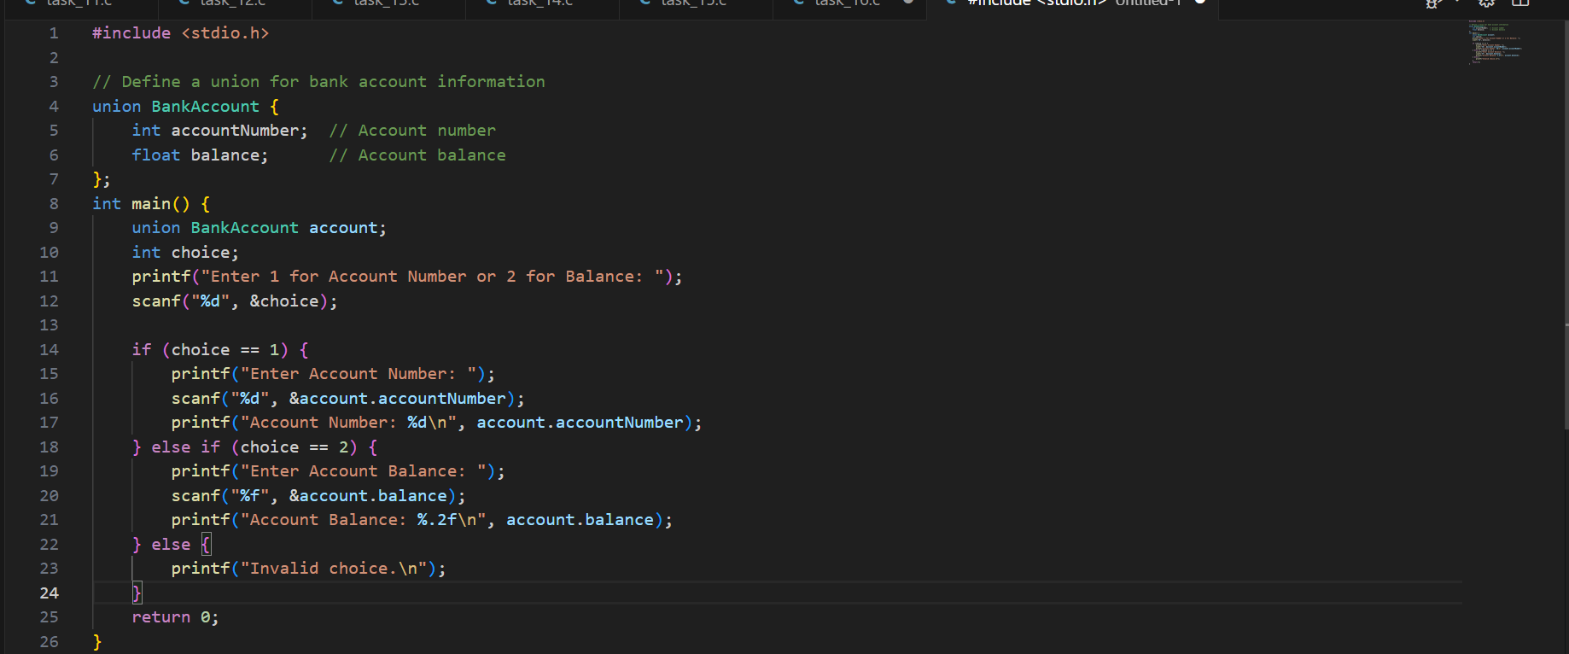

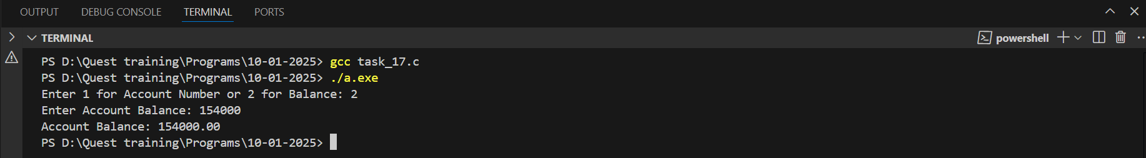

**Problem 8: Union for Vehicle Information**

**Description**: Define a union to store either the vehicle’s registration number (integer) or fuel capacity (float). Write a program to input and display either the registration number or fuel capacity.

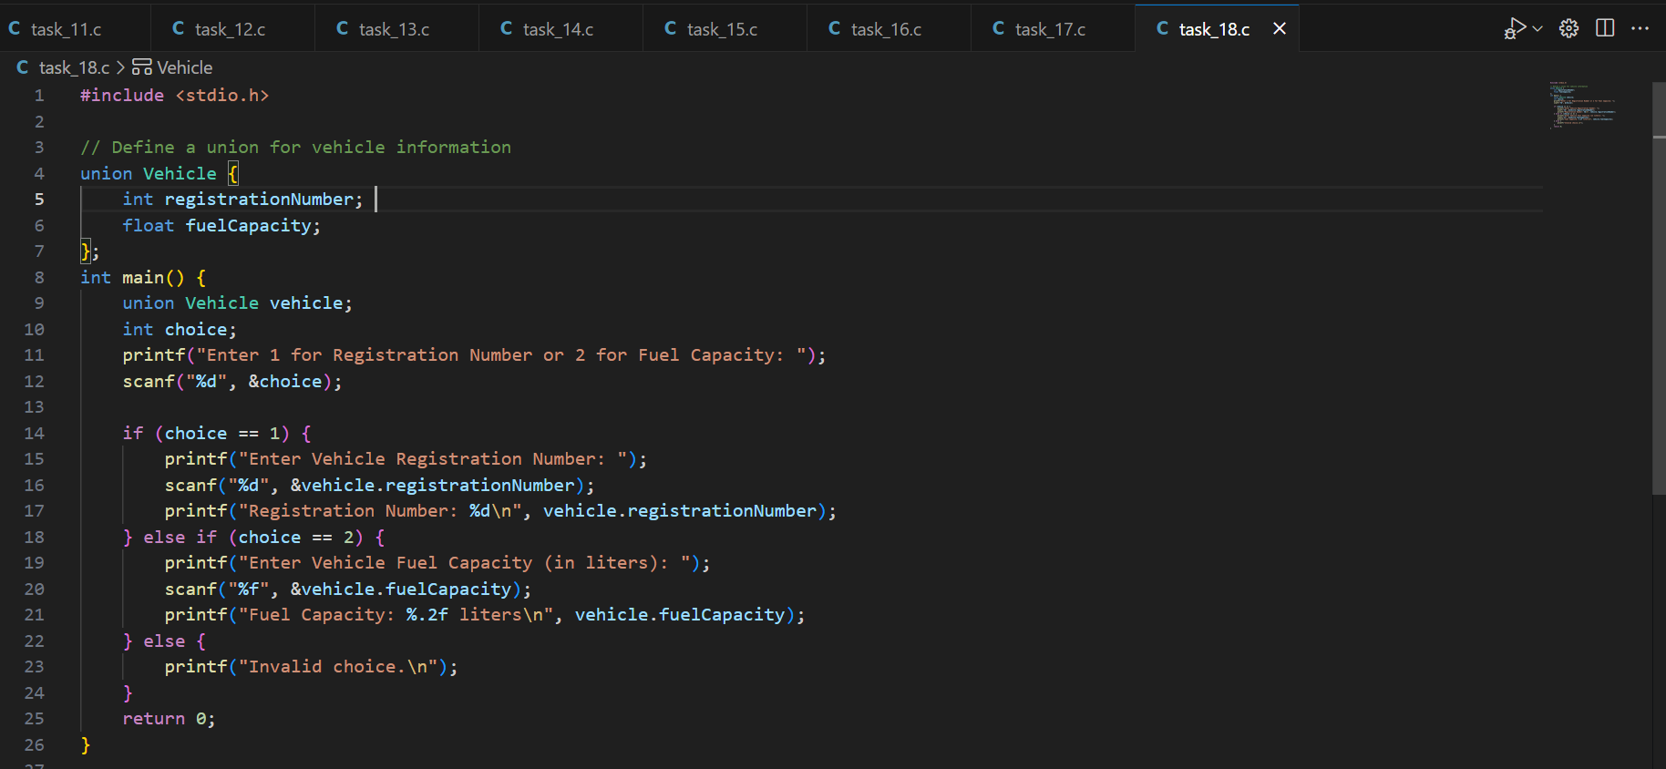

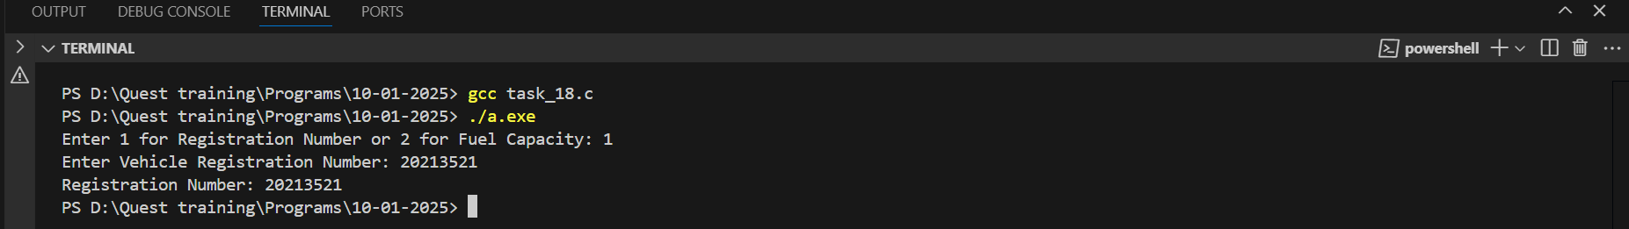

**Problem 9: Union for Exam Results**

**Description**: Create a union to store either a student’s marks (integer) or grade (char). Write a program to input marks or grade and display the corresponding value.

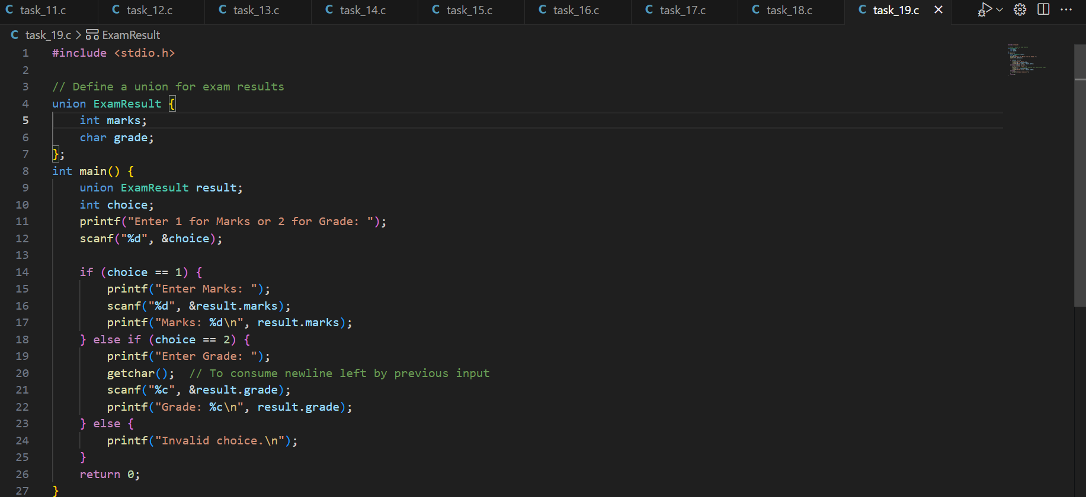



**Problem 10: Union for Currency Conversion**

**Description**: Define a union to store currency values in either USD (float) or EUR (float). Write a program to input a value in one currency and display the equivalent in the other.

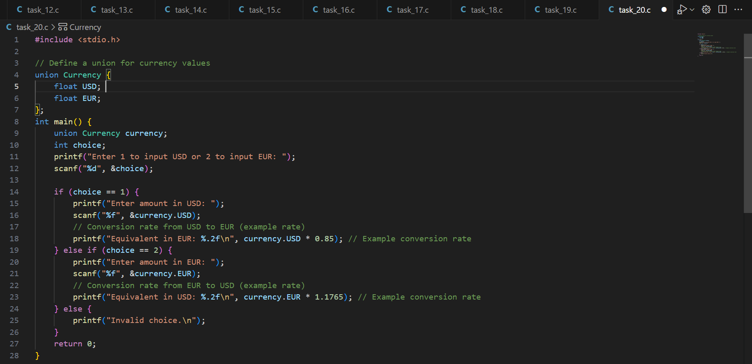

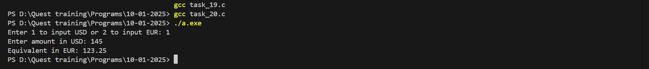

**Problem 1: Aircraft Fleet Management**

**Description**: Develop a system to manage a fleet of aircraft, tracking their specifications and operational status.

**Requirements**:

* Define a struct for Aircraft with fields: aircraftID, model, capacity, and status.
* Use an array of Aircraft structures.
* Implement functions to add new aircraft (call by reference), update status, and display fleet details (call by value).
* Use static to track the total number of aircraft.
* Utilize a switch case to manage different operational statuses.
* Employ loops to iterate through the fleet.

**Output Expectations**:

* Display updated fleet information after each operation.

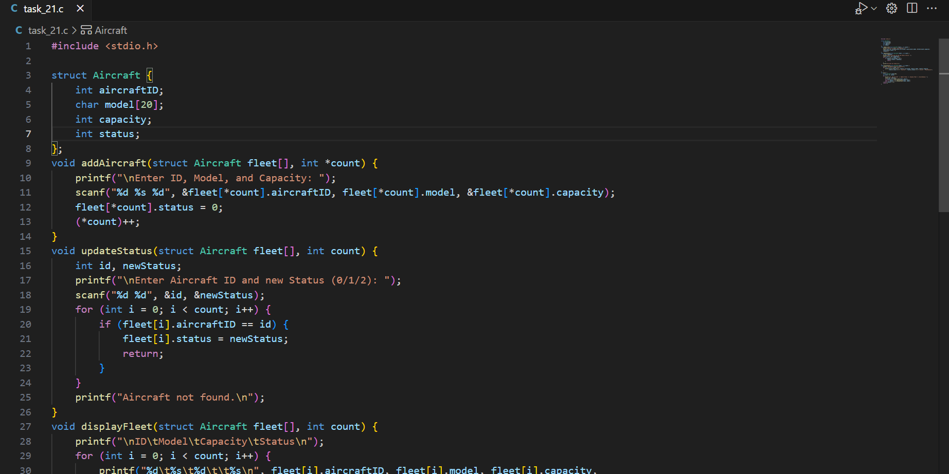

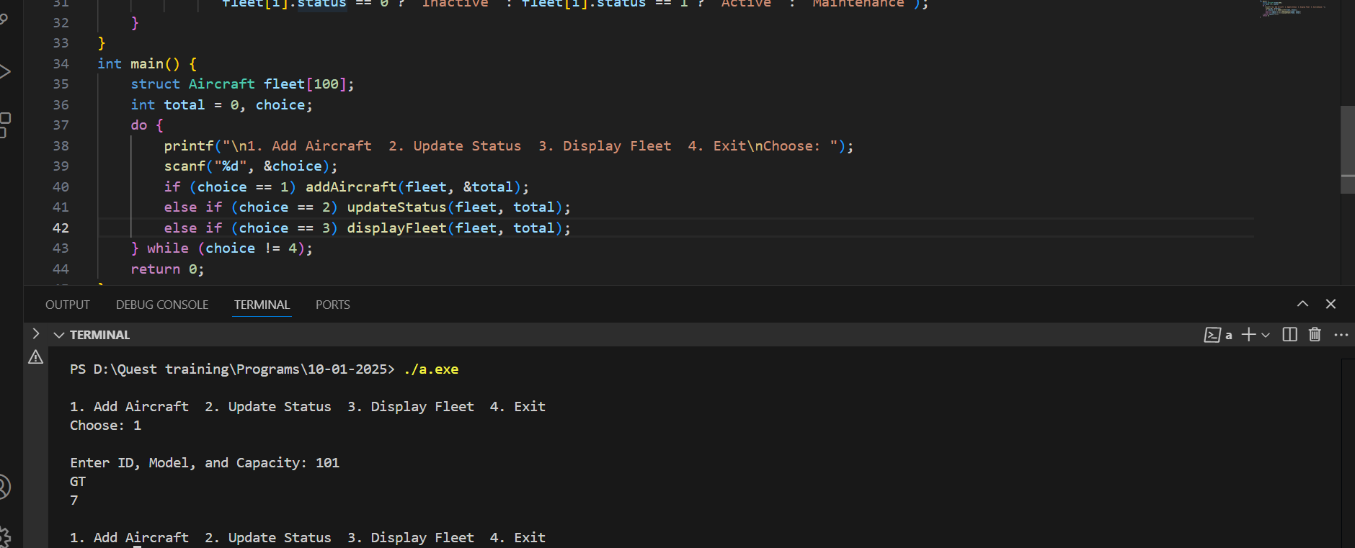

**Problem 2: Satellite Data Processing**

**Description**: Create a system to process and analyze satellite data.

**Requirements**:

* Define a union for SatelliteData to store either image data (array) or telemetry data (nested structure).
* Use struct to define Telemetry with fields: temperature, velocity, and altitude.
* Implement functions to process image and telemetry data (call by reference).
* Use const for fixed telemetry limits.
* Employ loops to iterate through data points.

**Output Expectations**:

* Display processed image or telemetry data based on user input.

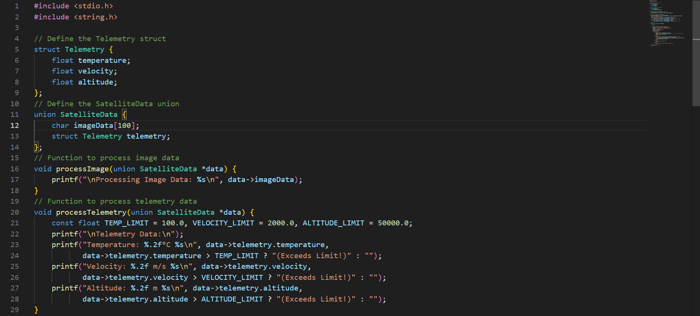

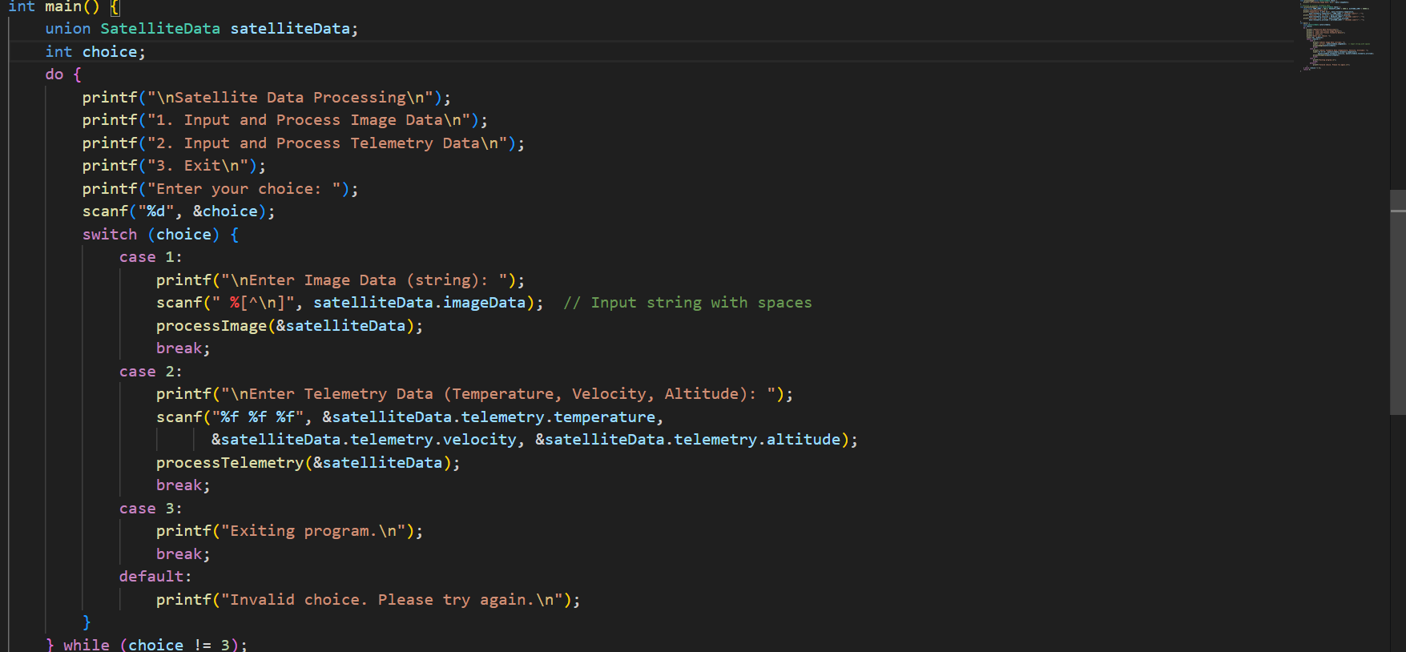

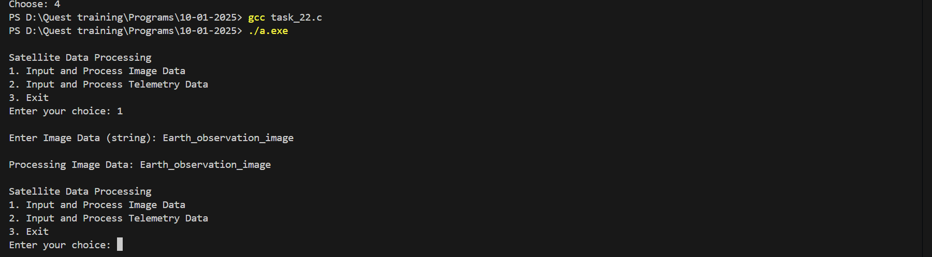

**Problem 3: Mission Control System**

**Description**: Develop a mission control system to manage spacecraft missions.

**Requirements**:

* Define a struct for Mission with fields: missionID, name, duration, and a nested union for payload (either crew details or cargo).
* Implement functions to add missions (call by reference), update mission details, and display mission summaries (call by value).
* Use static to count total missions.
* Use loops and switch case for managing different mission types.

**Output Expectations**:

* Provide detailed mission summaries including payload information.

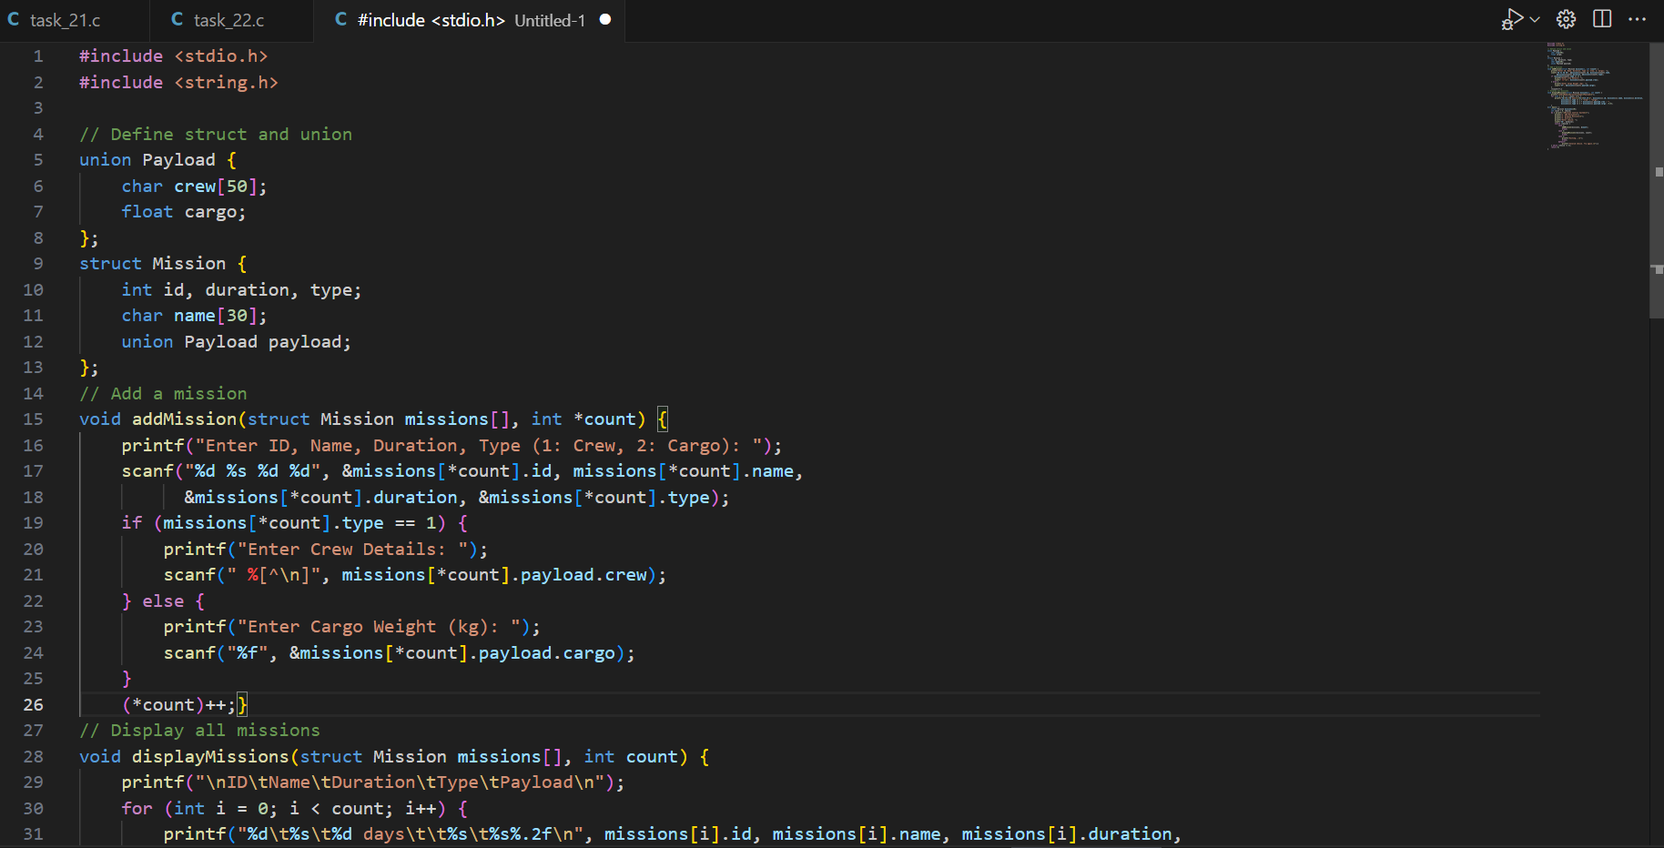

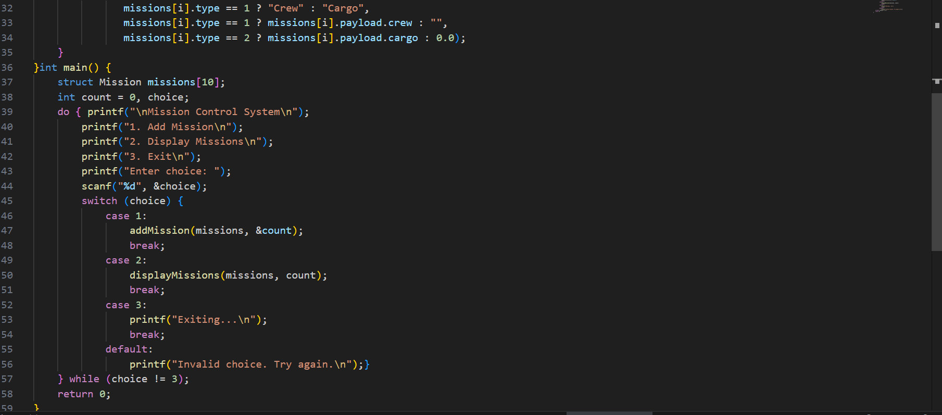

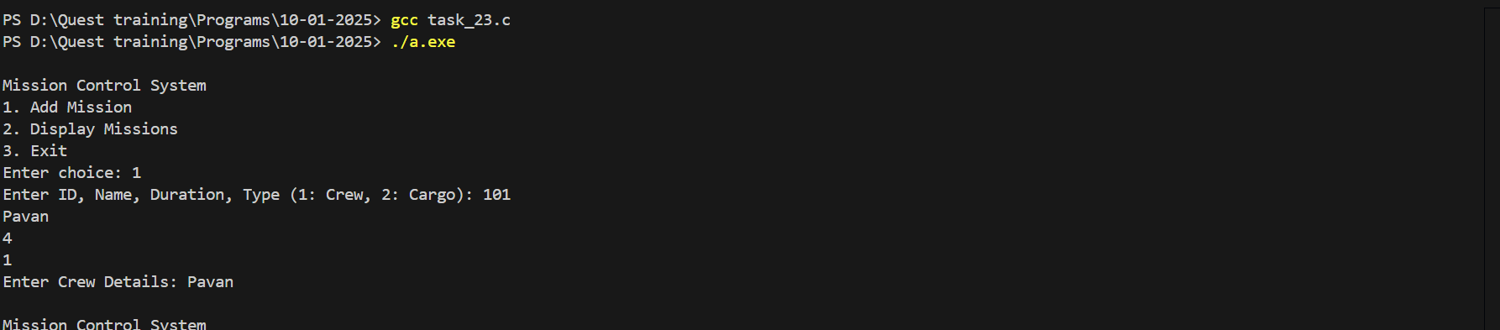

**Problem 4: Aircraft Maintenance Tracker**

**Description**: Create a tracker for aircraft maintenance schedules and logs.

**Requirements**:Use a struct for MaintenanceLog with fields: logID, aircraftID, date, and a nested union for maintenance type (routine or emergency).

* Implement functions to add maintenance logs (call by reference) and display logs (call by value).
* Use const for maintenance frequency. Employ loops to iterate through maintenance logs.

**Output Expectations**:Display maintenance logs categorized by type.

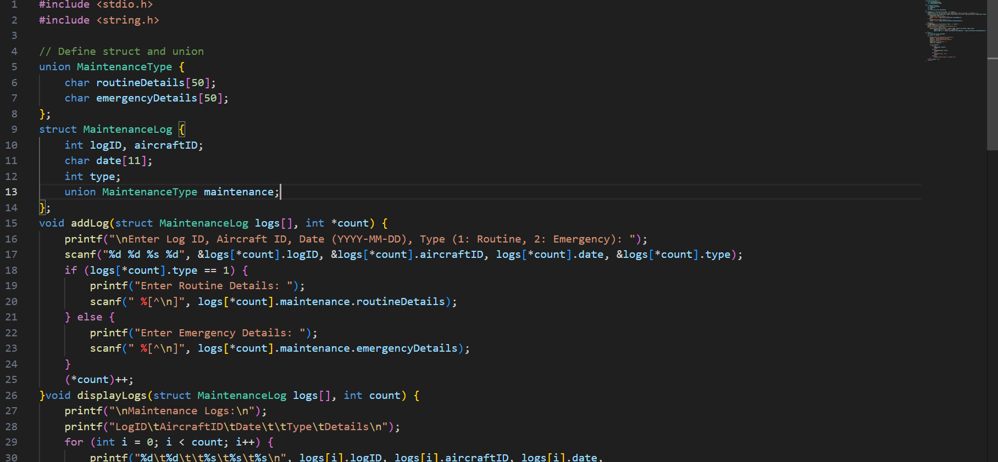

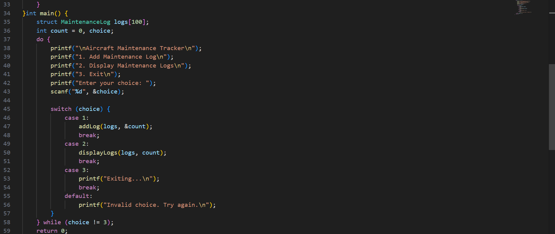

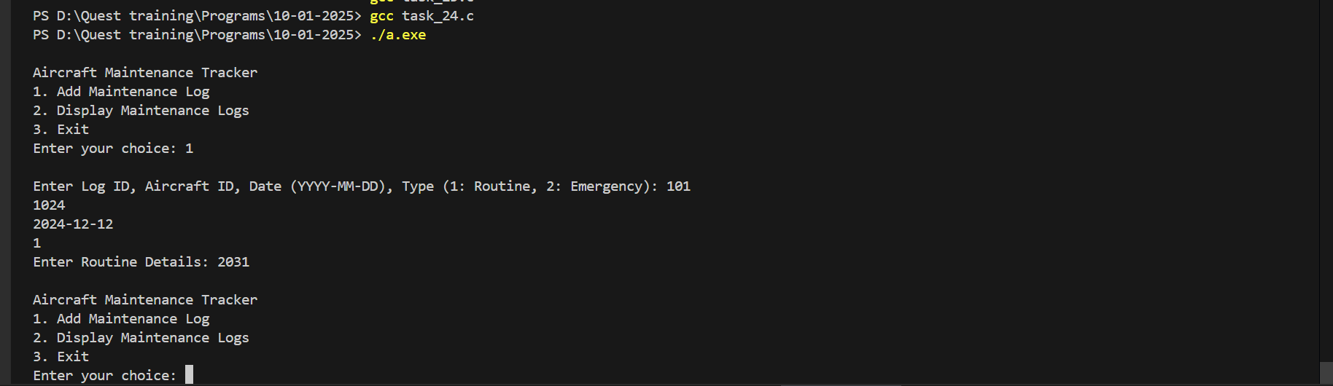

**Problem 5: Spacecraft Navigation System**

**Description**: Develop a navigation system for spacecraft to track their position and velocity.

**Requirements**:Define a struct for NavigationData with fields: position, velocity, and a nested union for navigation mode (manual or automatic).

* Implement functions to update navigation data (call by reference) and display the current status (call by value).
* Use static to count navigation updates. Use loops and switch case for managing navigation modes.

**Output Expectations**: Show updated position and velocity with navigation mode details.

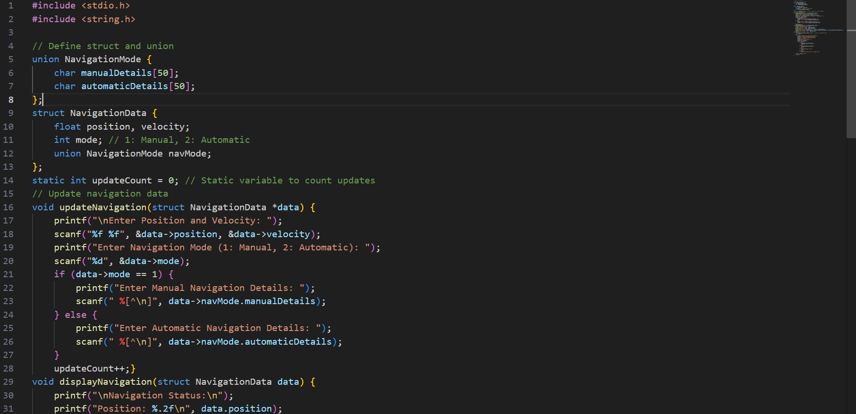

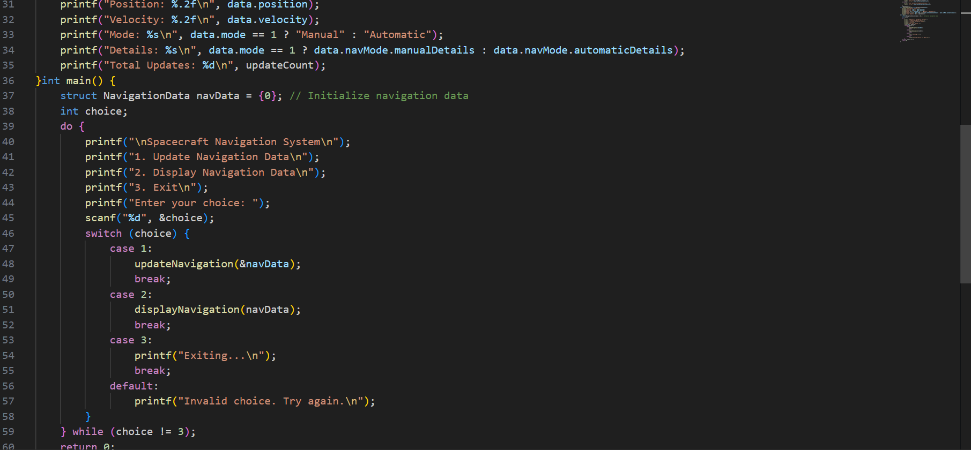

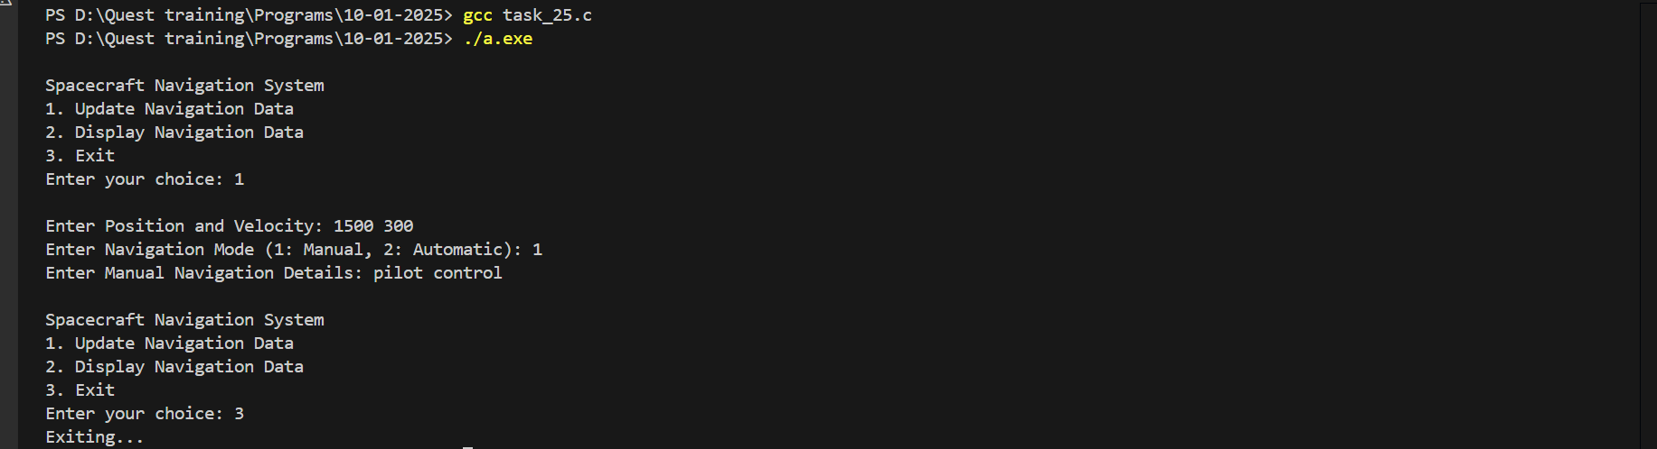

**Problem 6: Flight Simulation Control**

**Description**: Create a control system for flight simulations with different aircraft models.

**Requirements**: Define a struct for Simulation with fields: simulationID, aircraftModel, duration, and a nested union for control settings (manual or automated).

* Implement functions to start simulations (call by reference), update settings, and display simulation results (call by value).
* Use const for fixed simulation parameters.Utilize loops to run multiple simulations and a switch case for selecting control settings.

**Output Expectations**: Display simulation results with control settings.

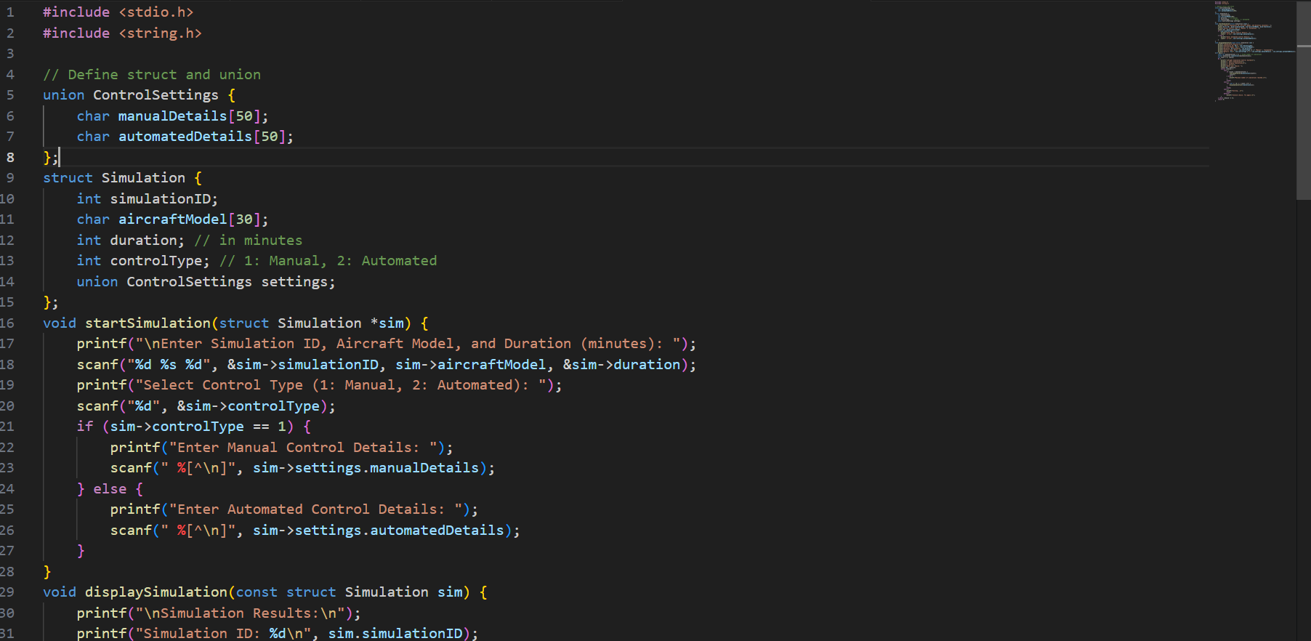 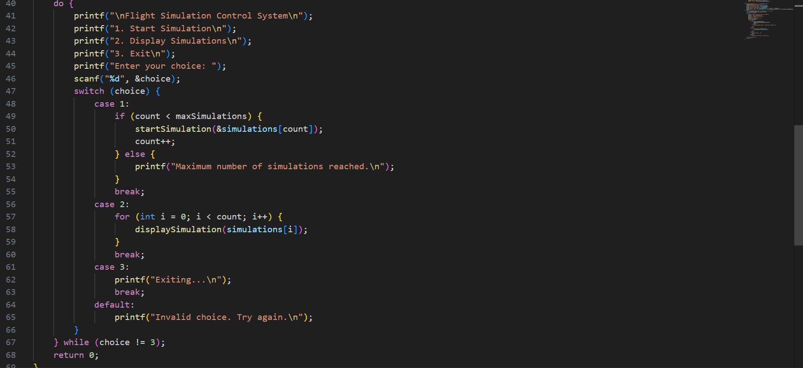

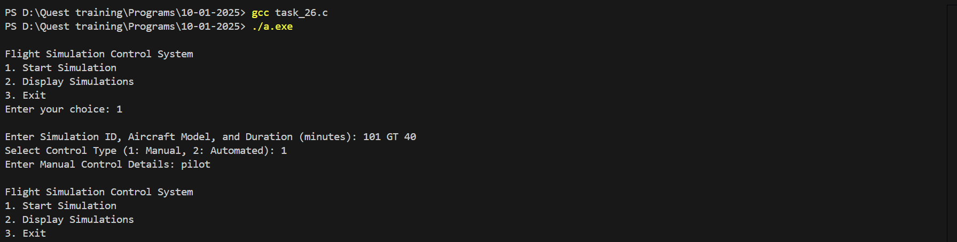

**Problem 7: Aerospace Component Testing**

**Description**: Develop a system for testing different aerospace components.

**Requirements**: Use a struct for ComponentTest with fields: testID, componentName, and a nested union for test data (physical or software).

* Implement functions to record test results (call by reference) and display summaries (call by value).
* Use static to count total tests conducted. Employ loops and switch case for managing different test types.

**Output Expectations**: Display test results categorized by component type.

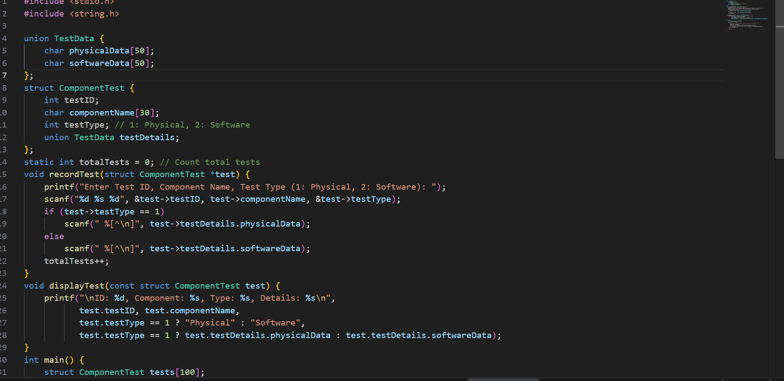

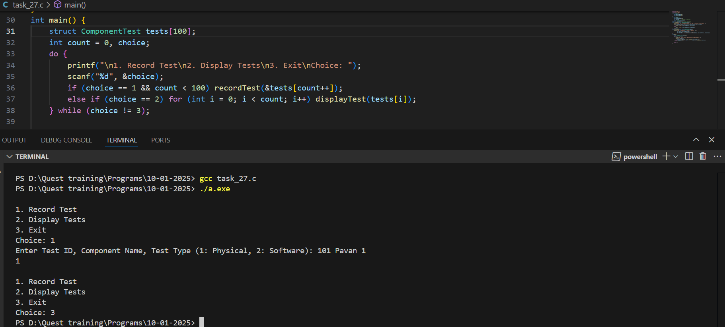

**Problem 8: Space Station Crew Management**

**Description**: Create a system to manage crew members aboard a space station.

**Requirements**:Define a struct for CrewMember with fields: crewID, name, role, and a nested union for role-specific details (engineer or scientist).

* Implement functions to add crew members (call by reference), update details, and display crew lists (call by value).
* Use const for fixed role limits. Use loops to iterate through the crew list and a switch case for role management.

**Output Expectations**:Show updated crew information including role-specific details.

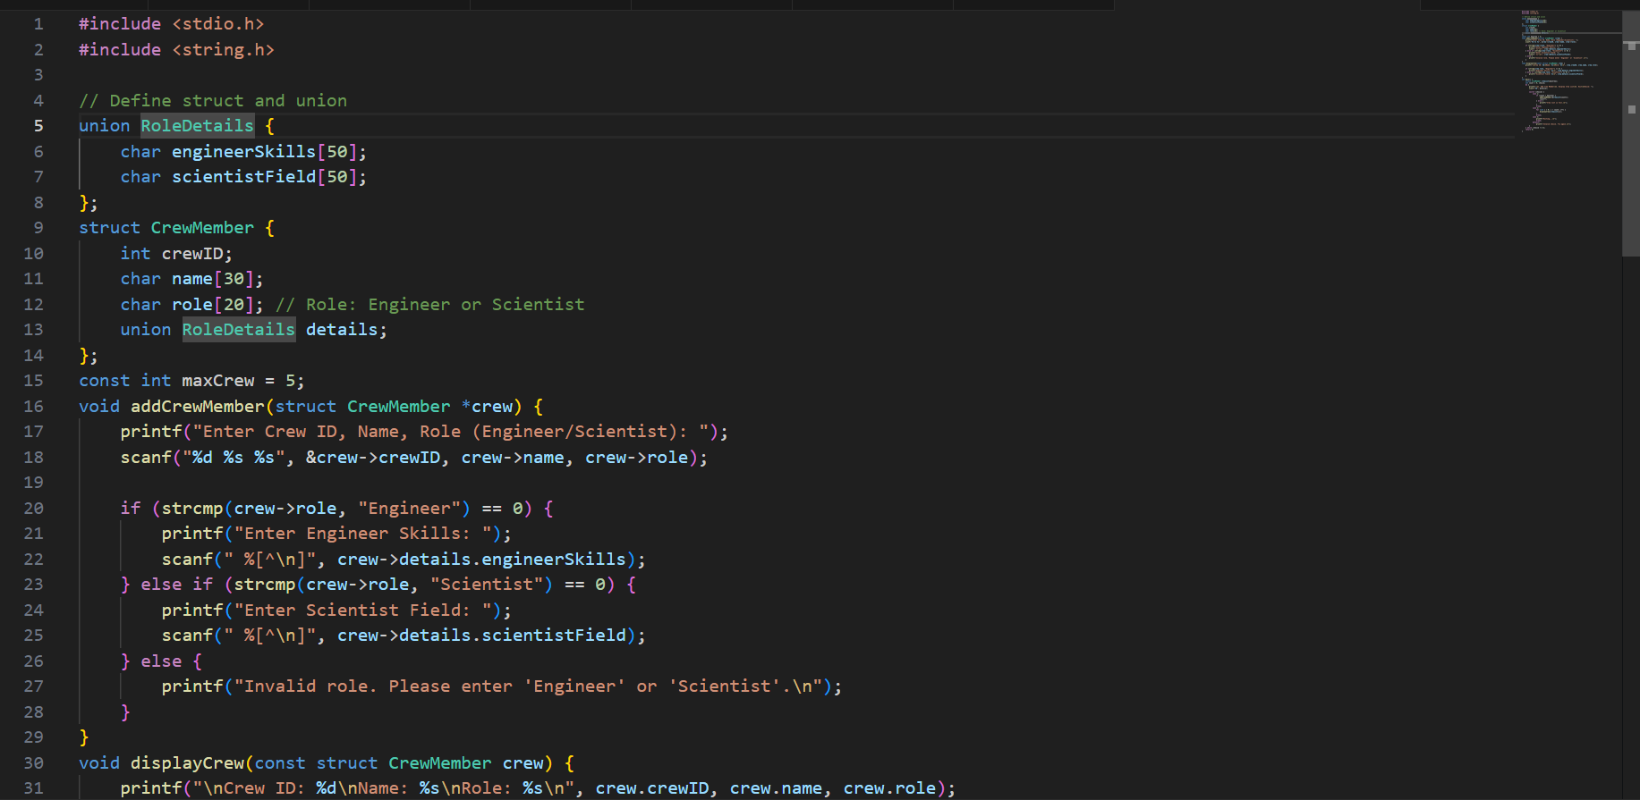

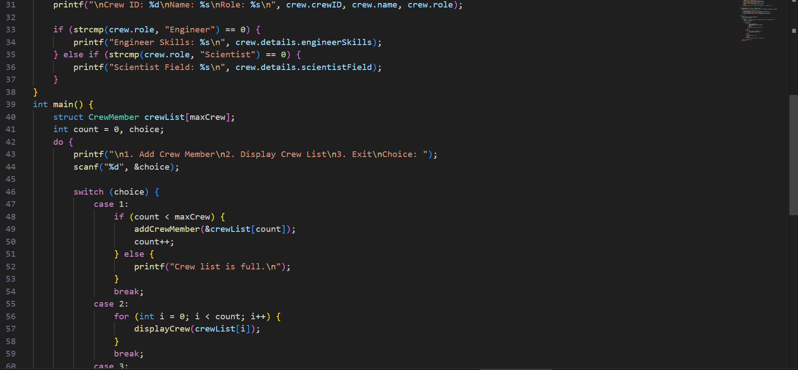

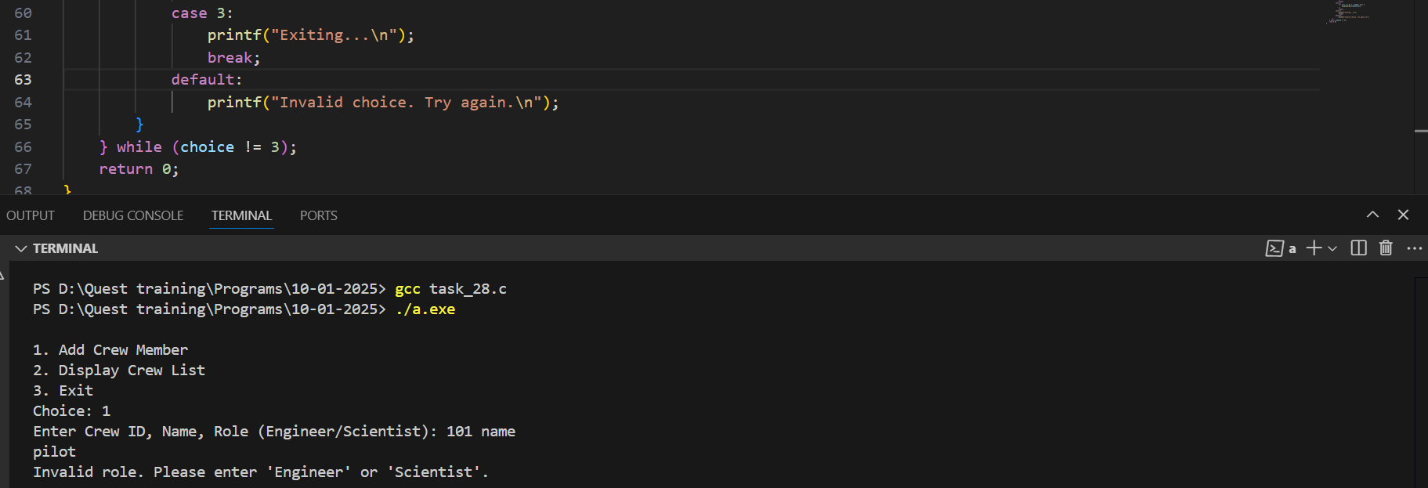

**Problem 9: Aerospace Research Data Analysis**

**Description**: Develop a system to analyze research data from aerospace experiments.

**Requirements**: Use a struct for ResearchData with fields: experimentID, description, and a nested union for data type (numerical or qualitative).

* Implement functions to analyze data (call by reference) and generate reports (call by value).
* Use static to track the number of analyses conducted. Employ loops and switch case for managing different data types.

**Output Expectations**: Provide detailed reports of analyzed data.

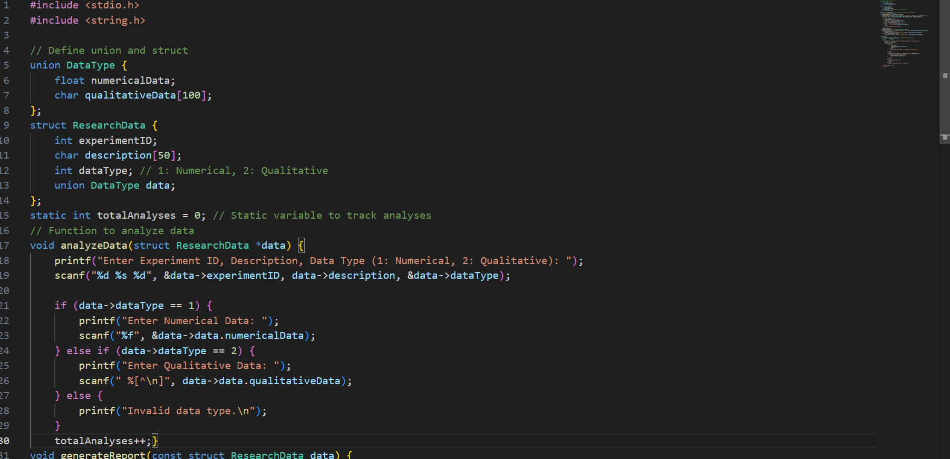

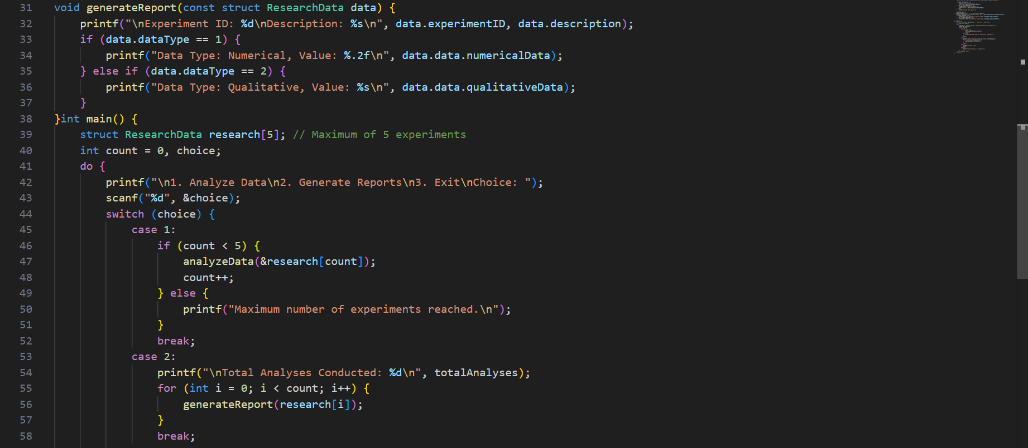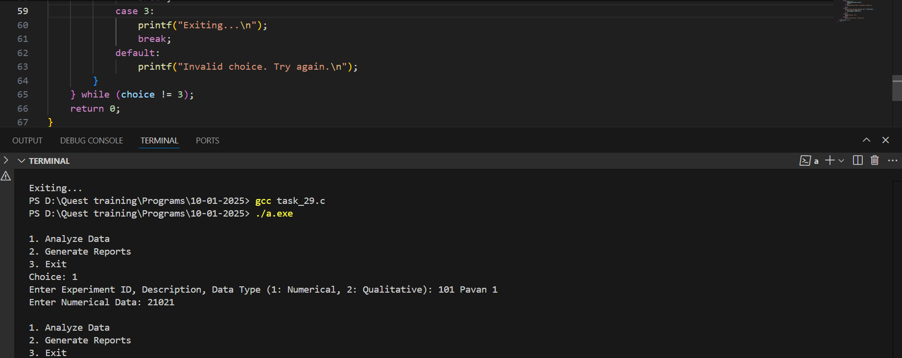

**Problem 10: Rocket Launch Scheduler**

**Description**: Create a scheduler for managing rocket launches.

**Requirements**:Define a struct for Launch with fields: launchID, rocketName, date, and a nested union for launch status (scheduled or completed).

* Implement functions to schedule launches (call by reference), update statuses, and display launch schedules (call by value).
* Use const for fixed launch parameters. Use loops to iterate through launch schedules and a switch case for managing status updates.

**Output Expectations**:Display detailed launch schedules and statuses.

